ECEN 325

Lab 7: Characterization and Biasing of the BJT

Section 506

03/27/2020

Jason Gilman

TA: Mandela

**Calculations:**

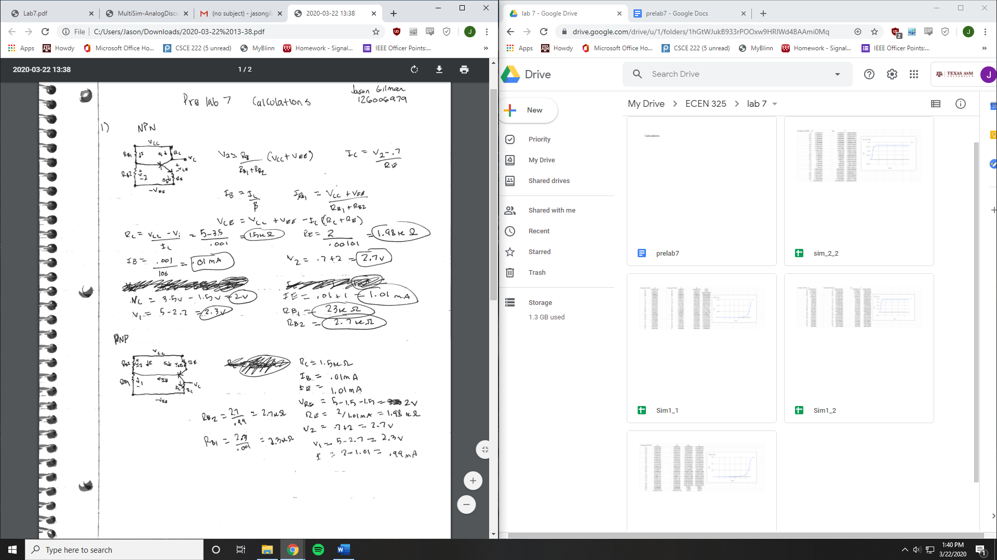

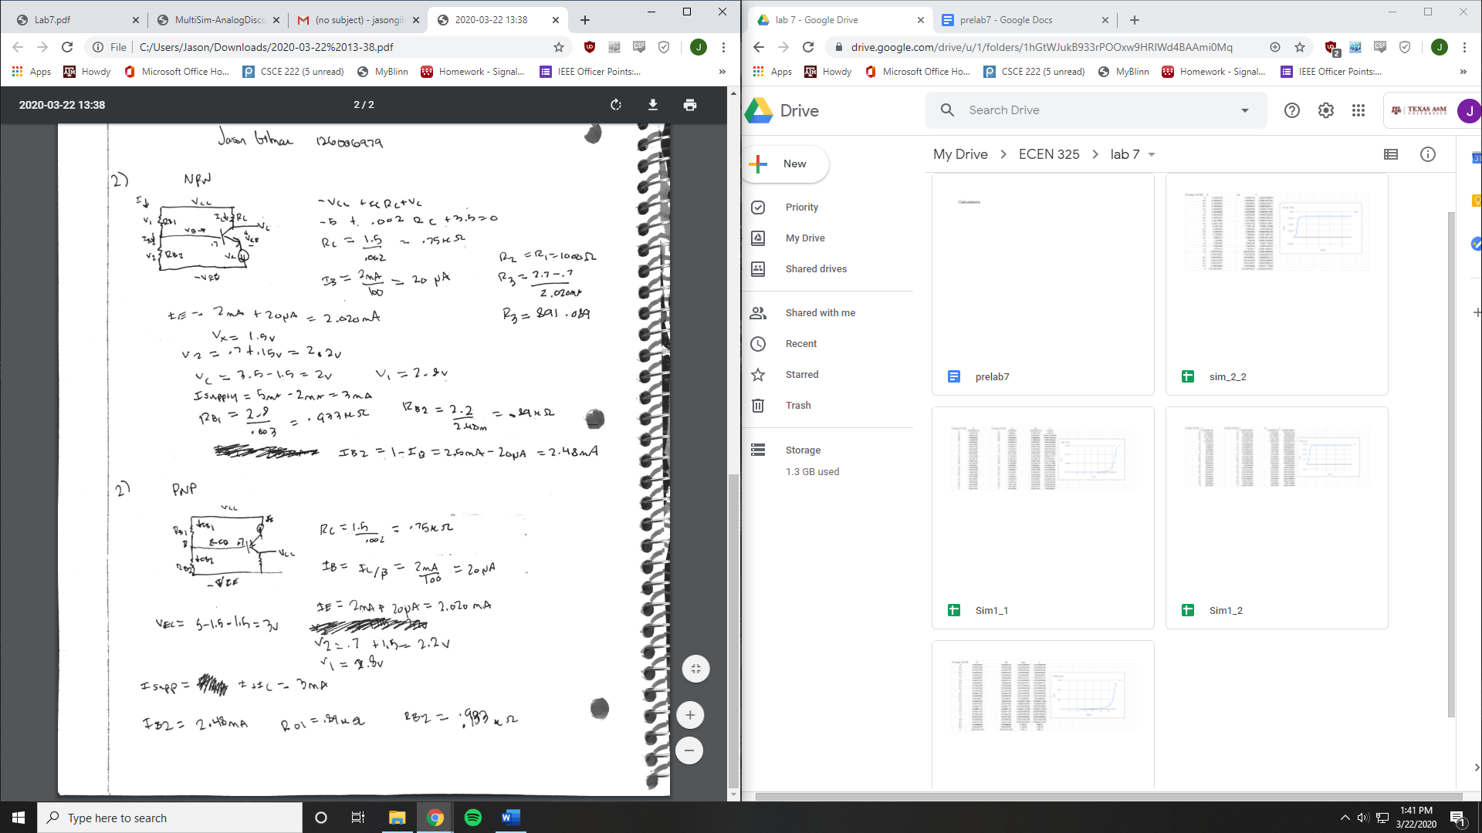

**Simulations:**

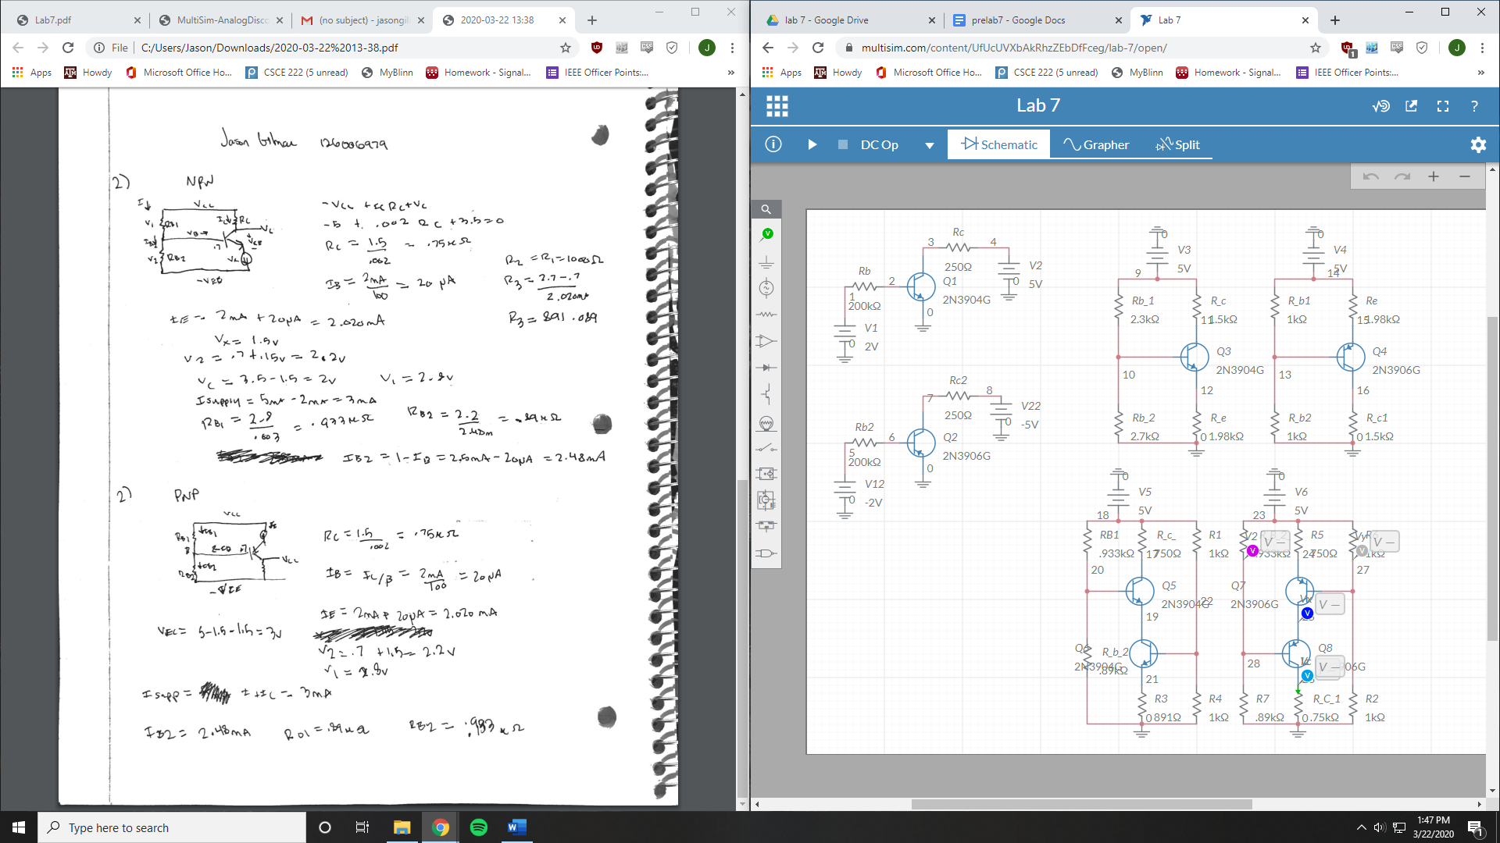

NPN BJT

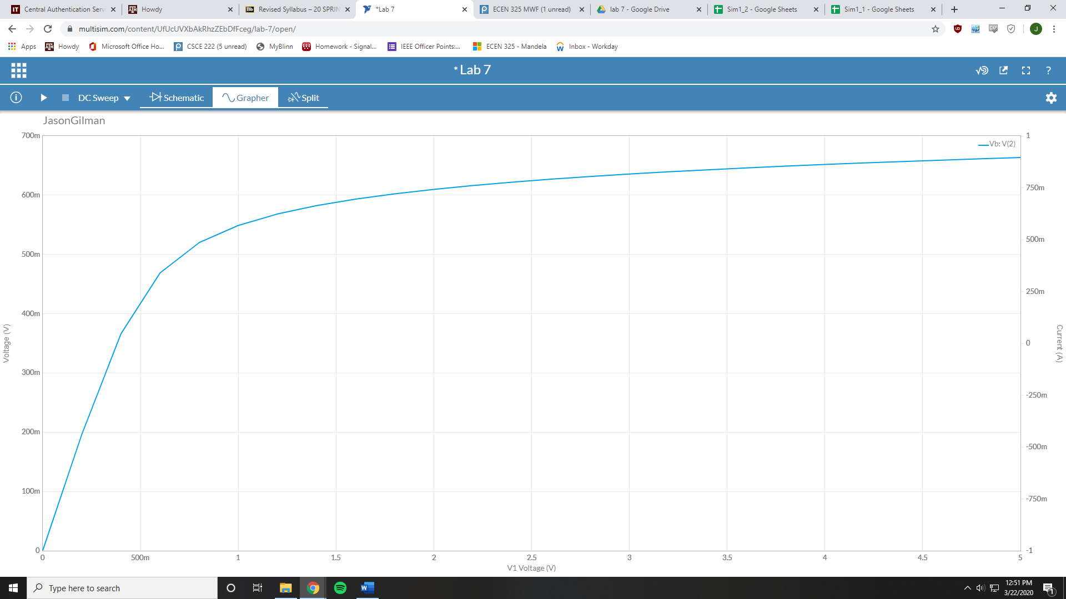

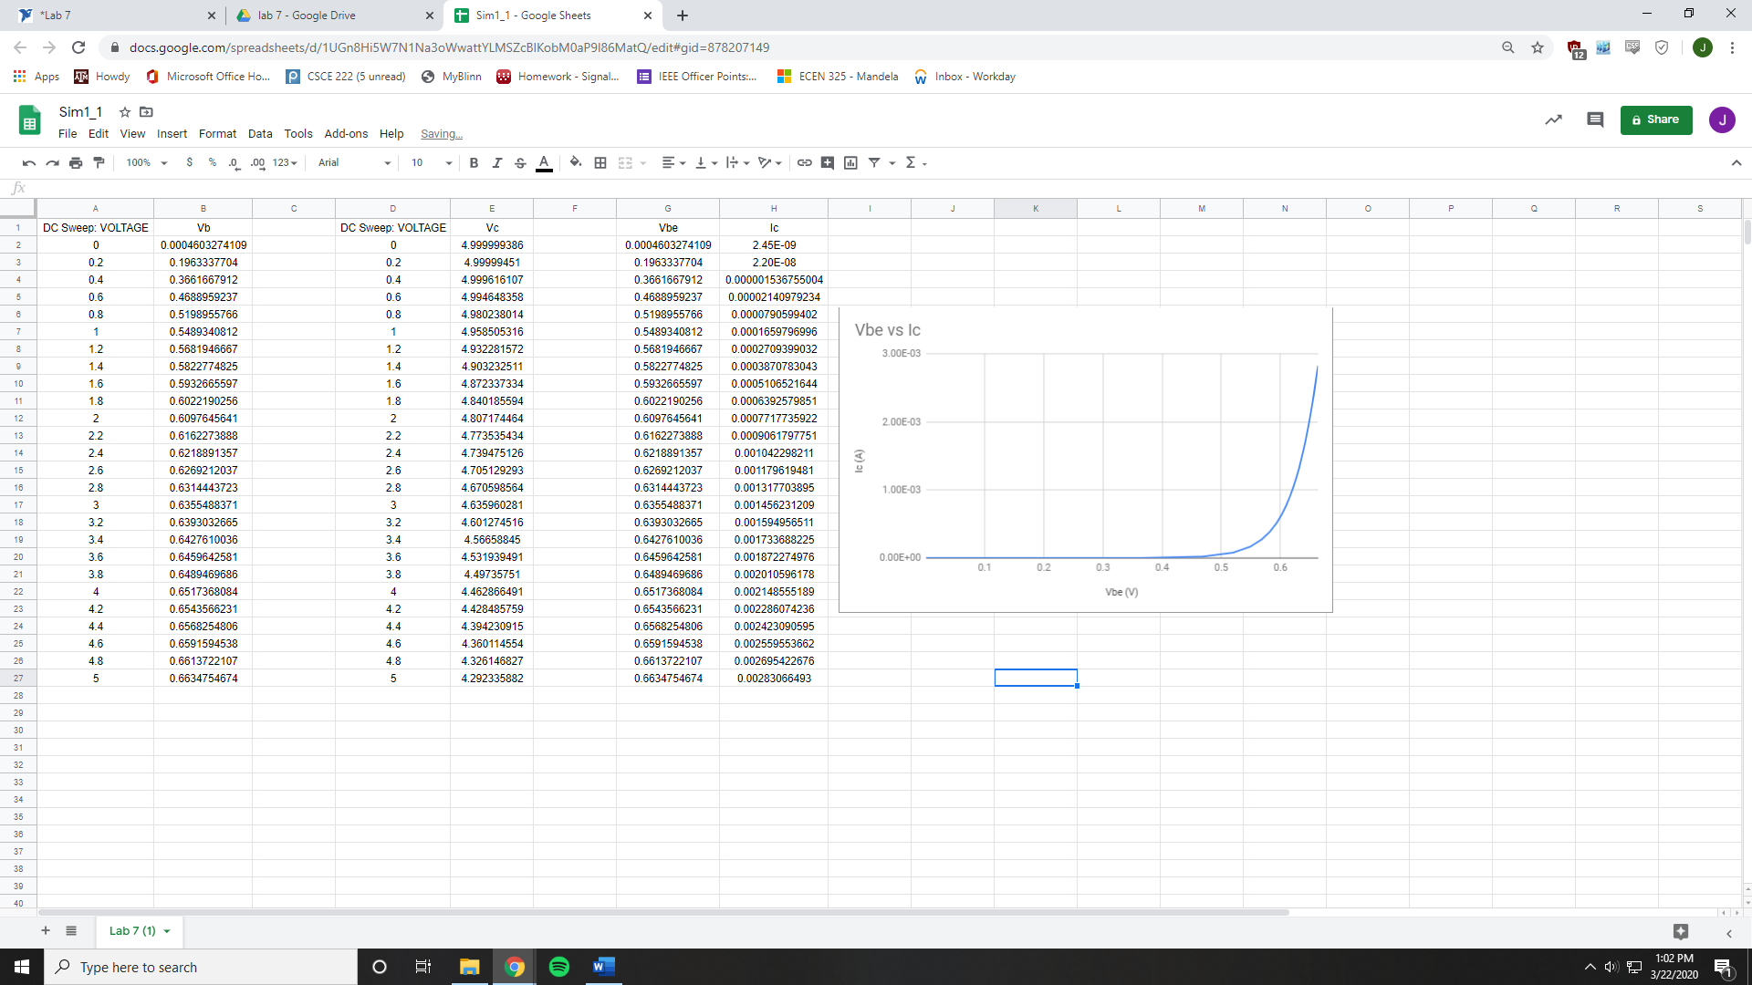

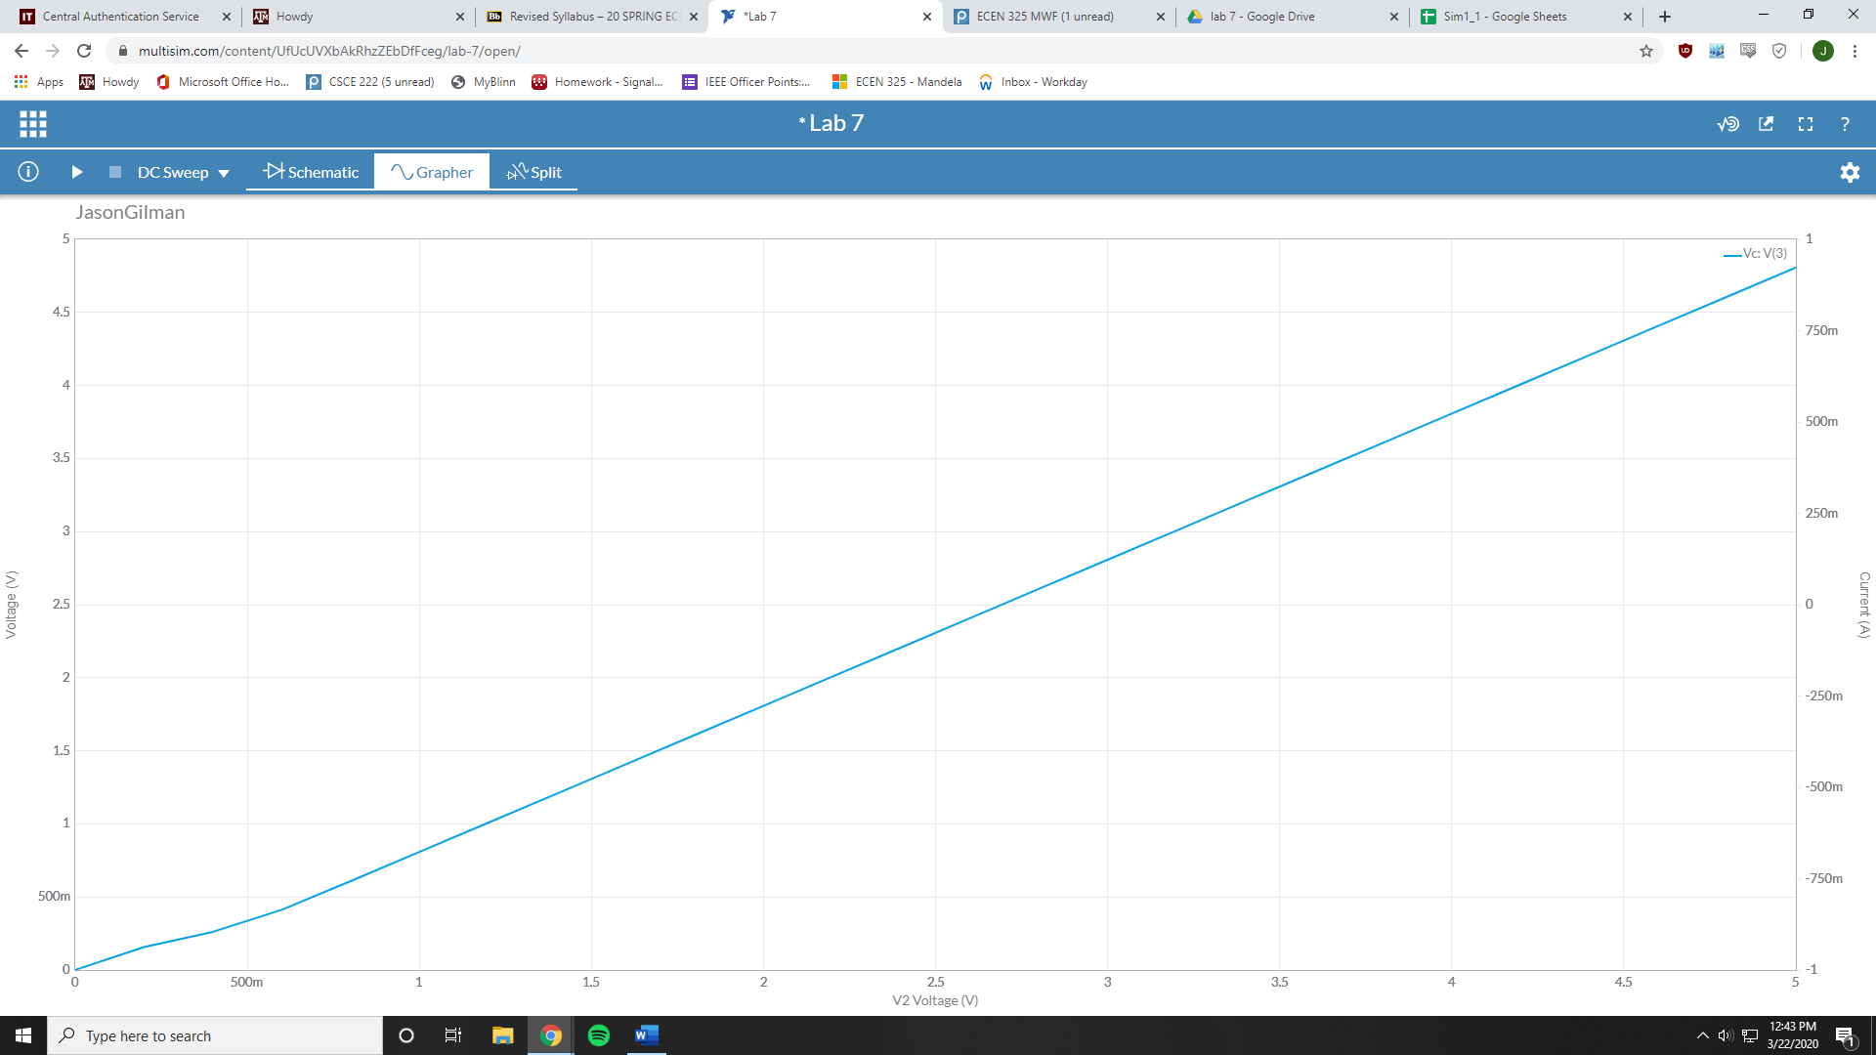

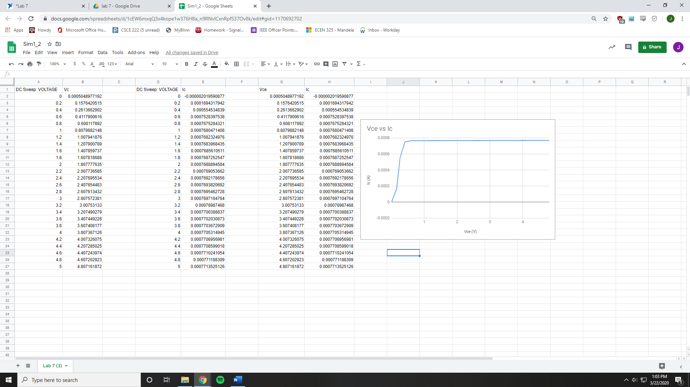

PNP BJT

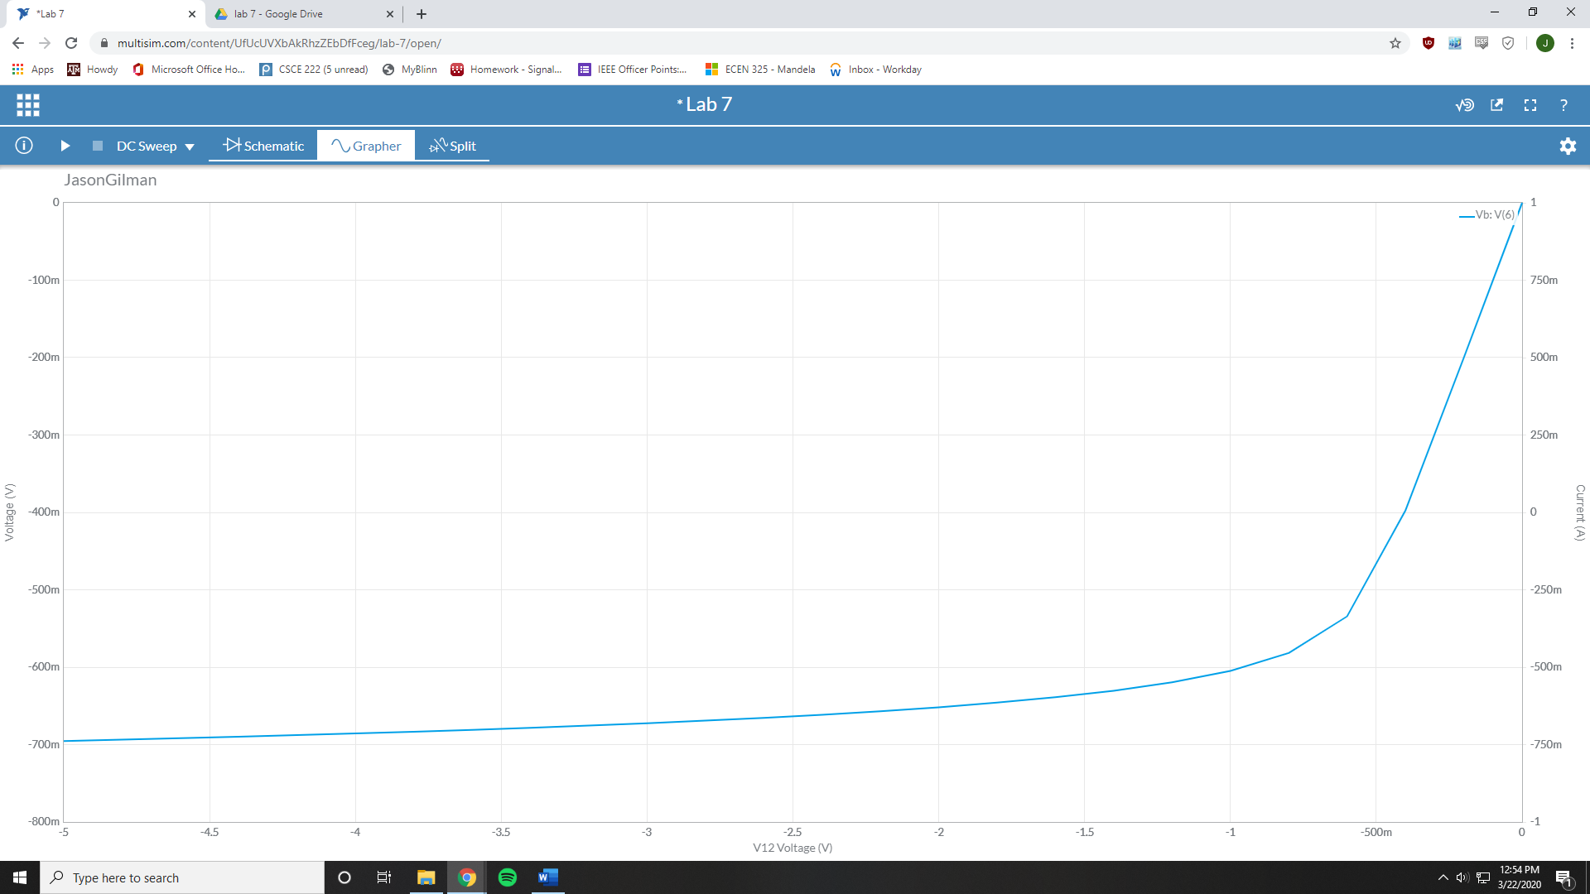

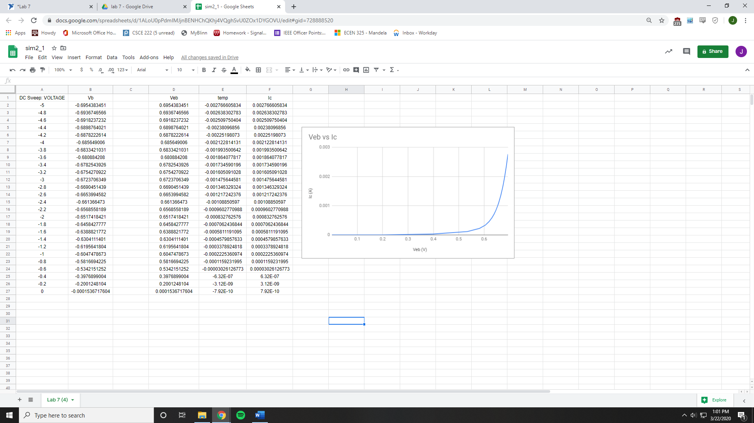

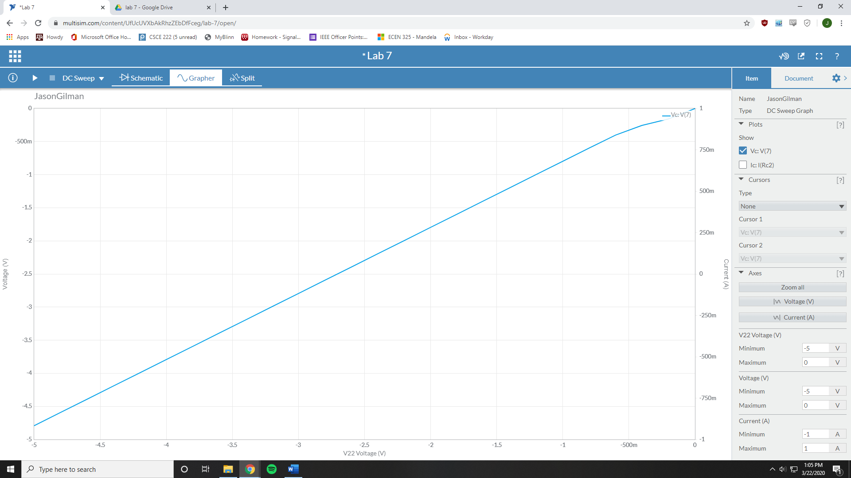

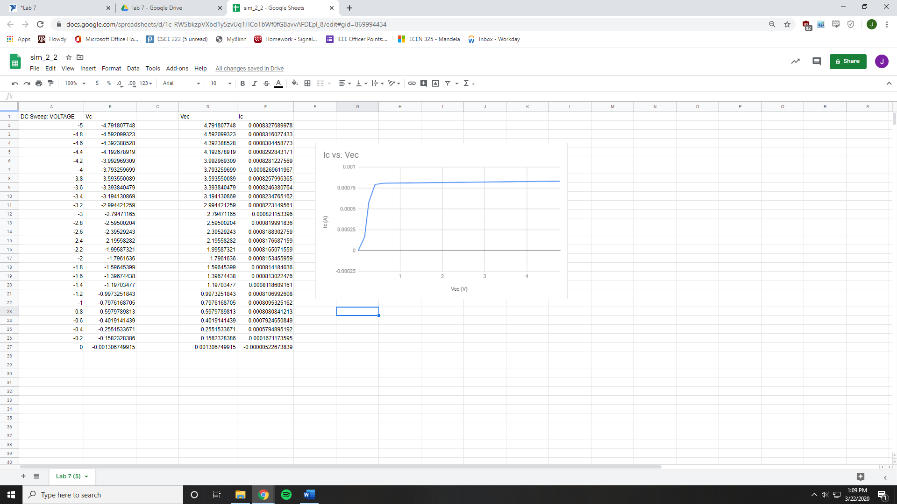

NPN Resistive DC Biasing

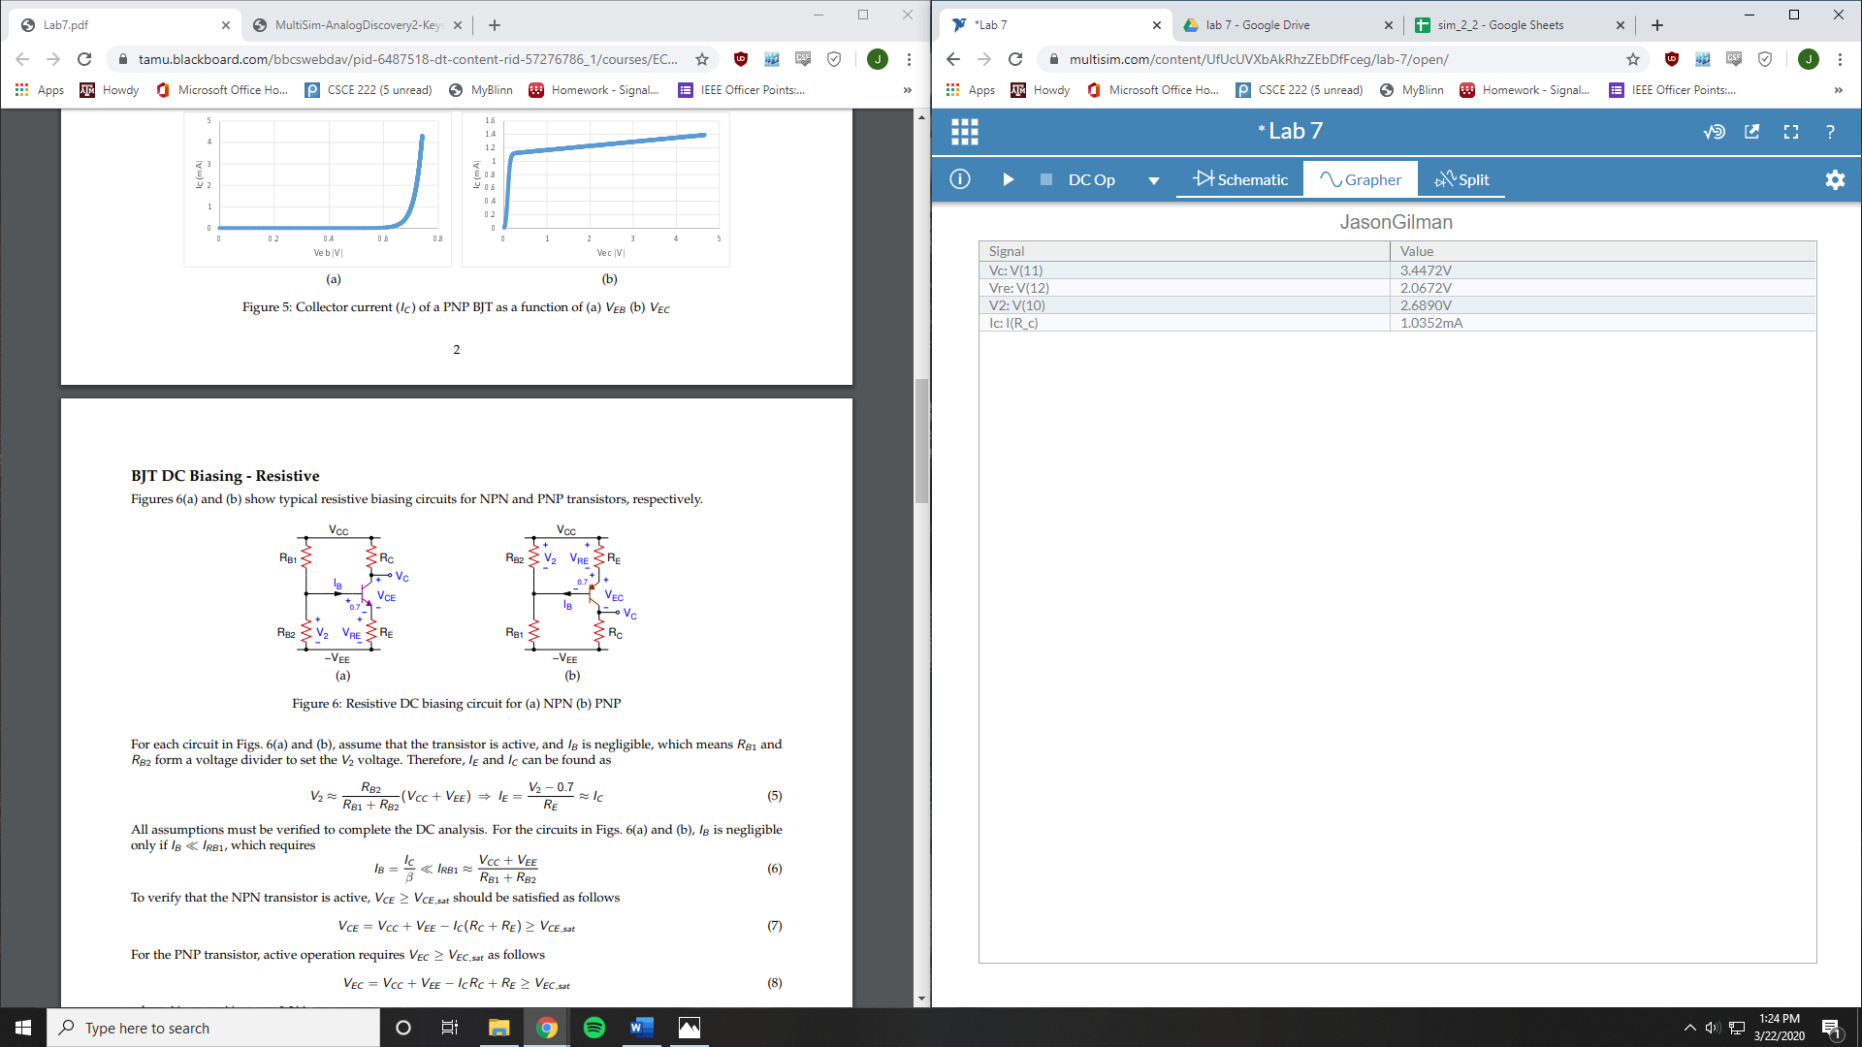

PNP Resistive DC Biasing

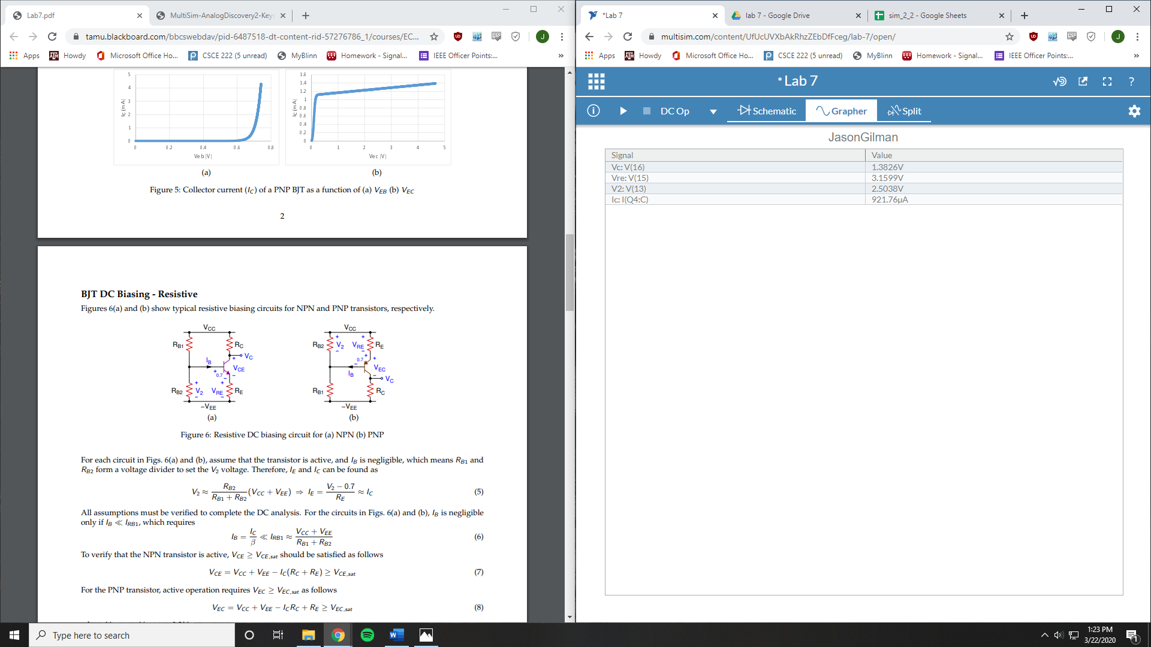

NPN DC Biasing

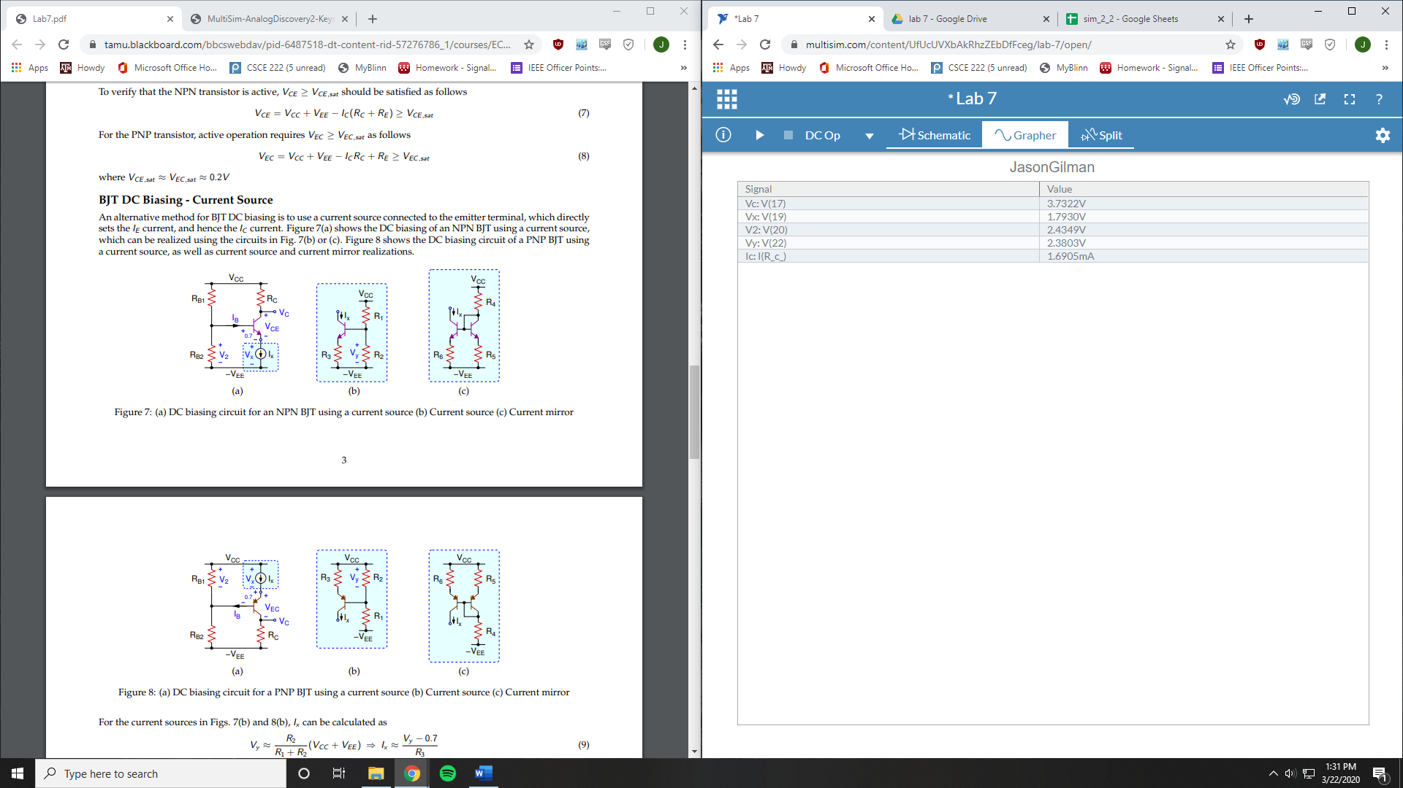

PNP DC Biasing

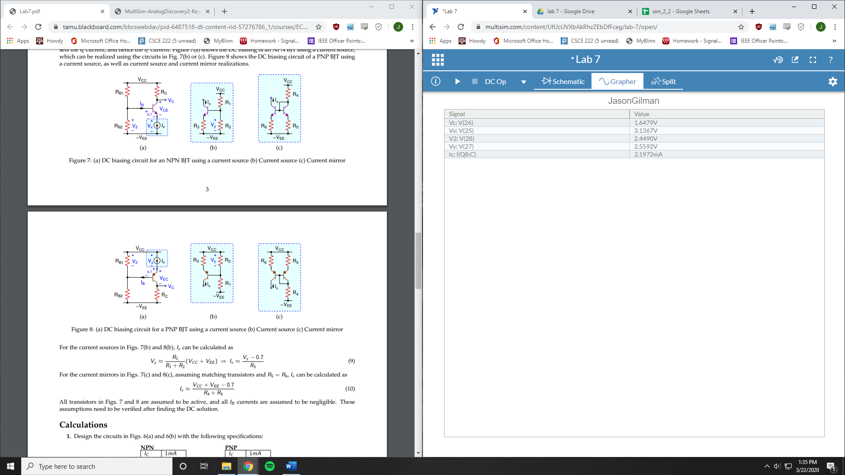

**Measurements:**

NPN BJT

V1 Sweep

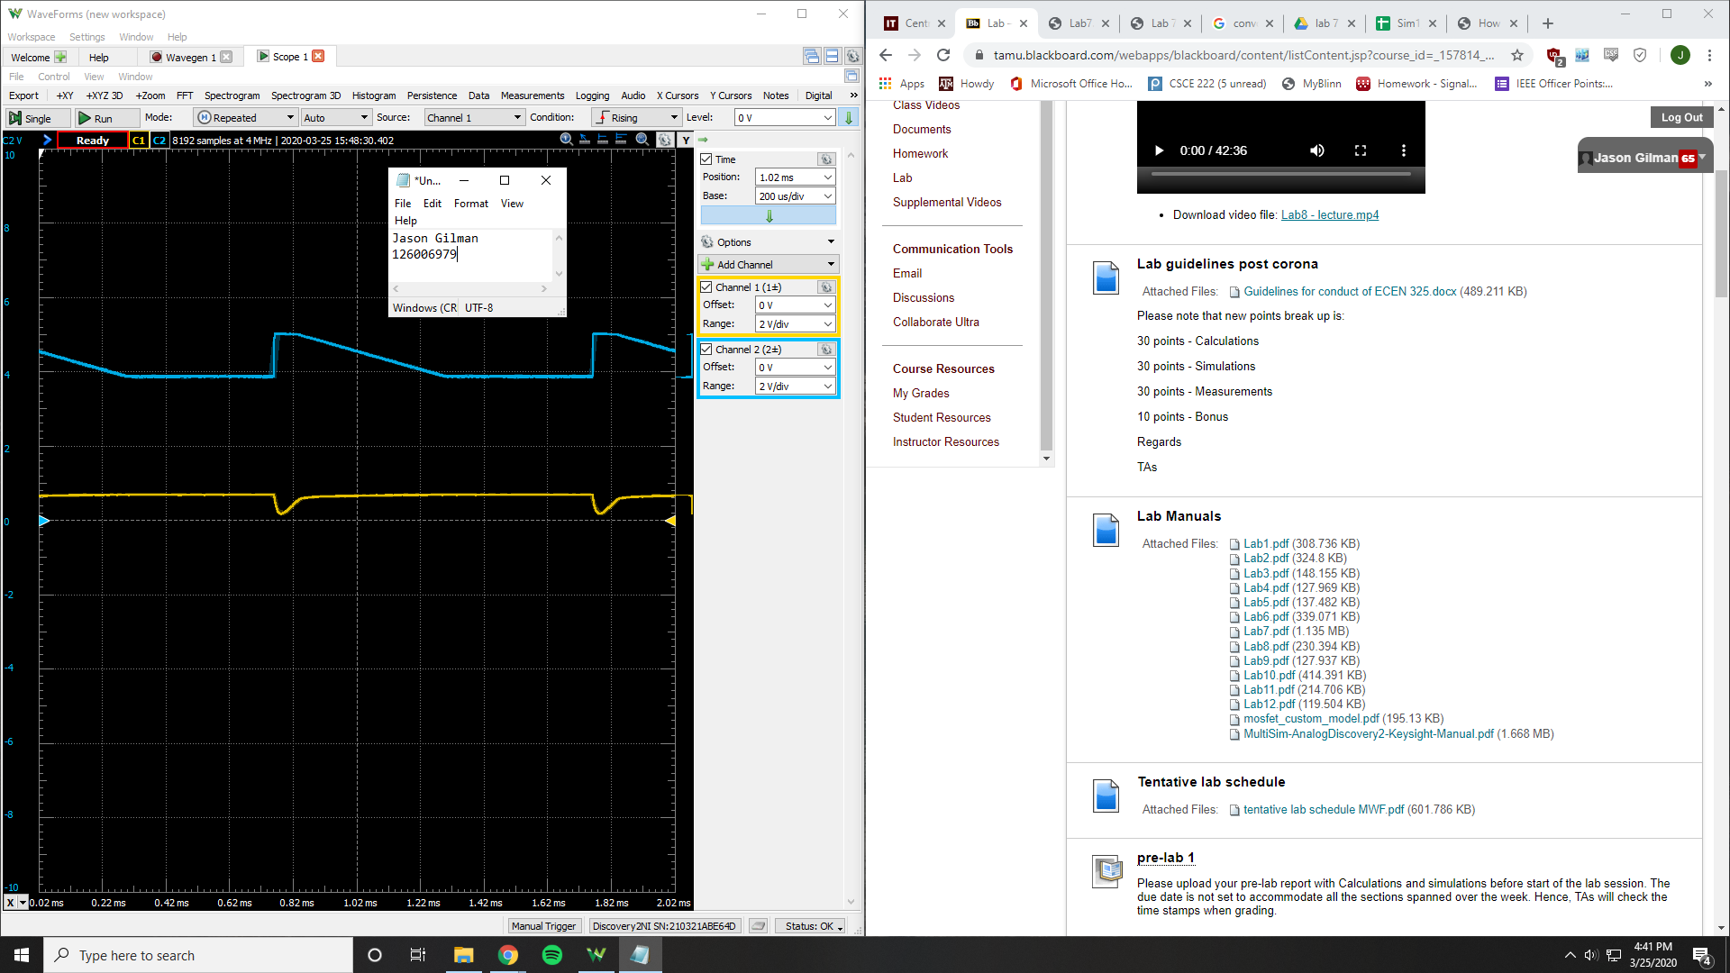

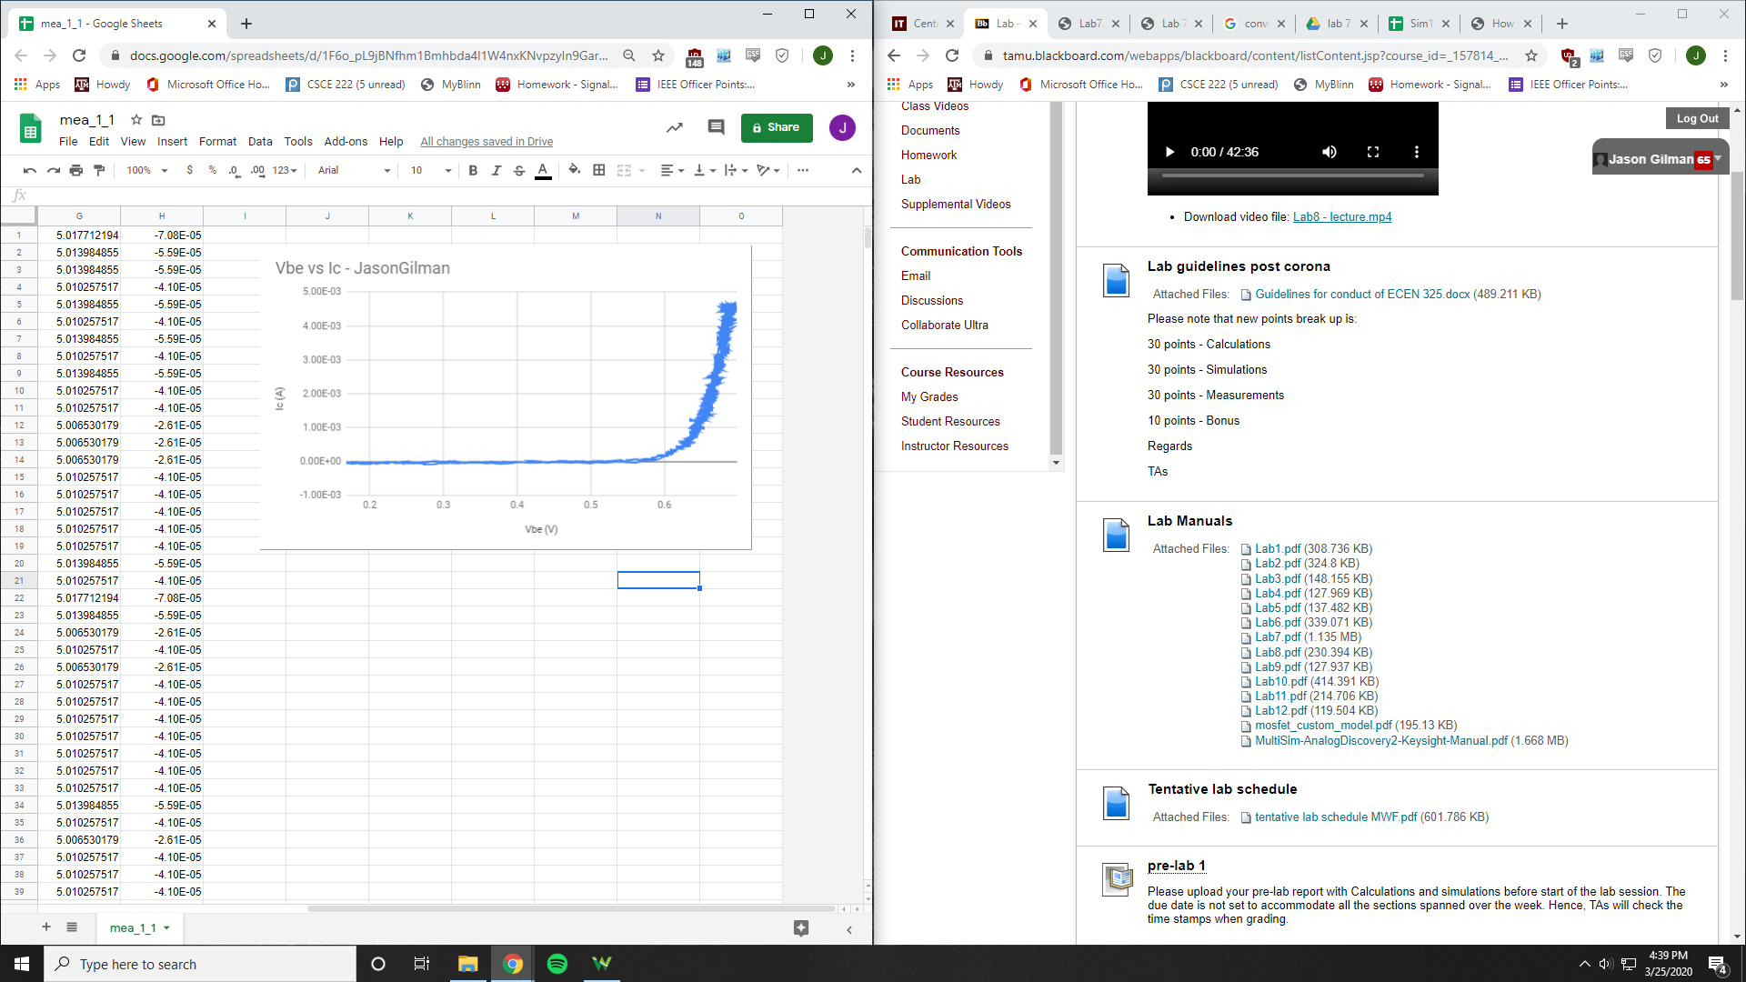

V2 Sweep

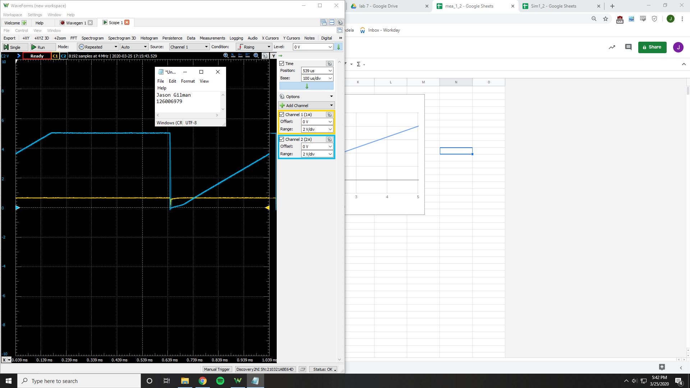

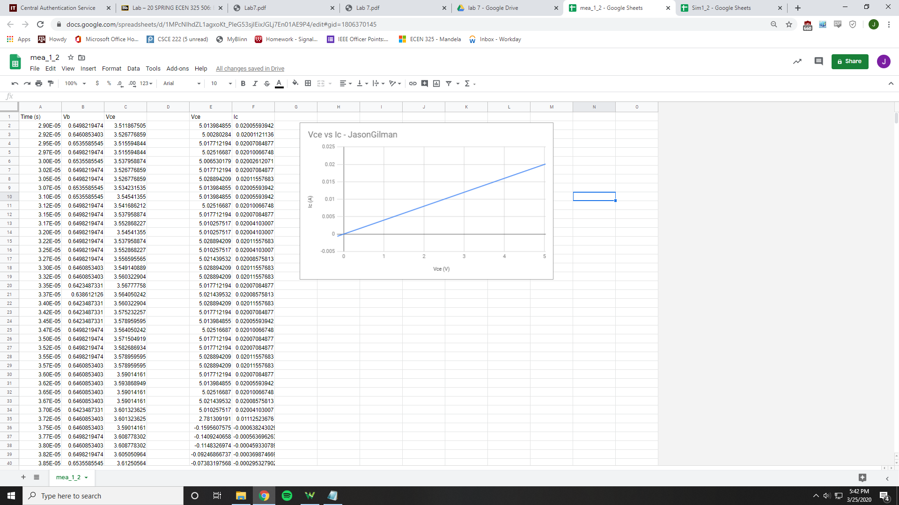

PNP BJT

V1 Sweep

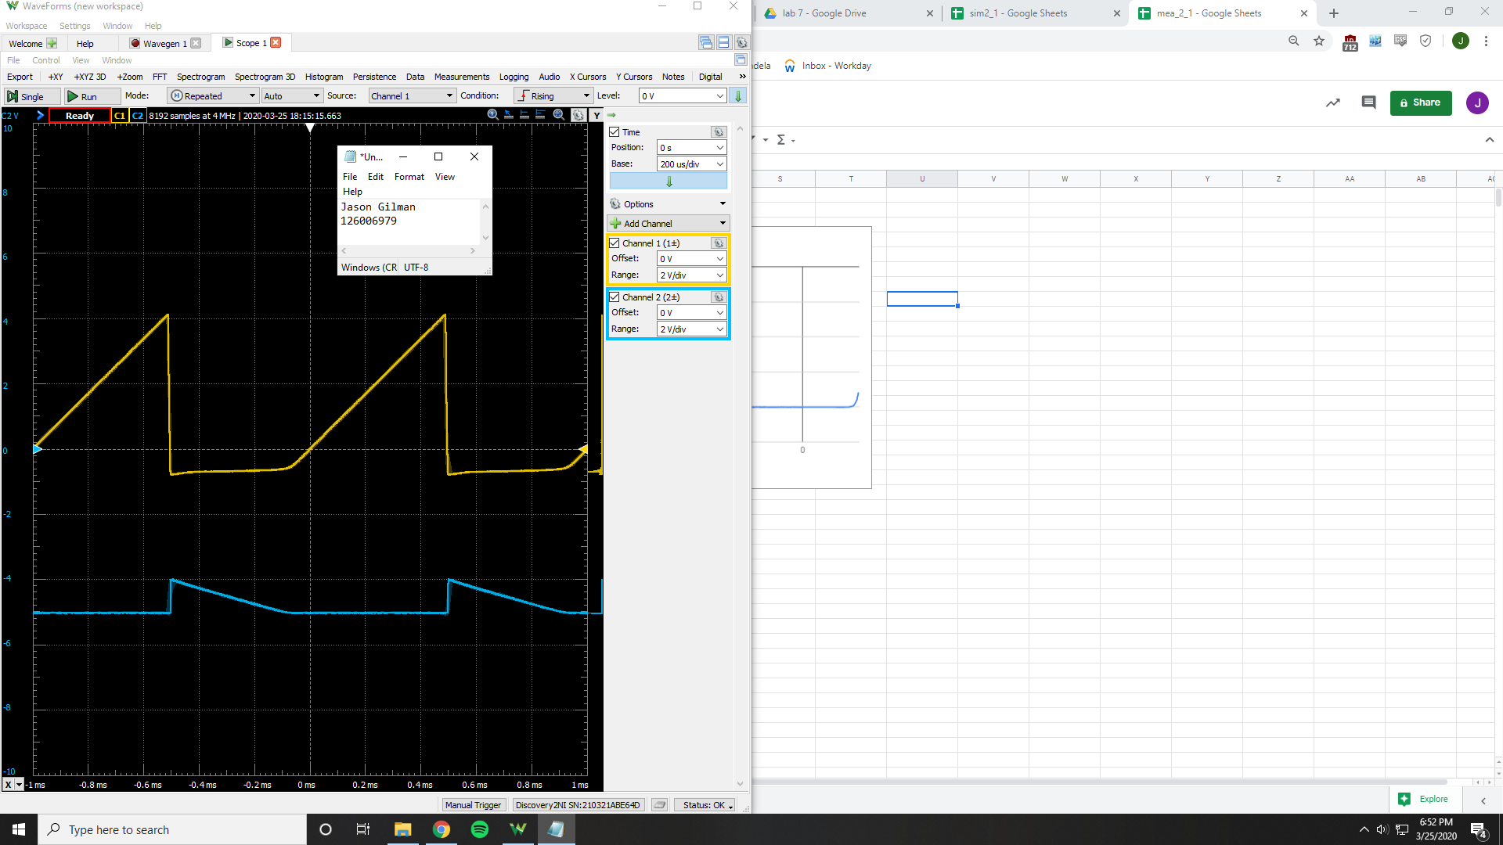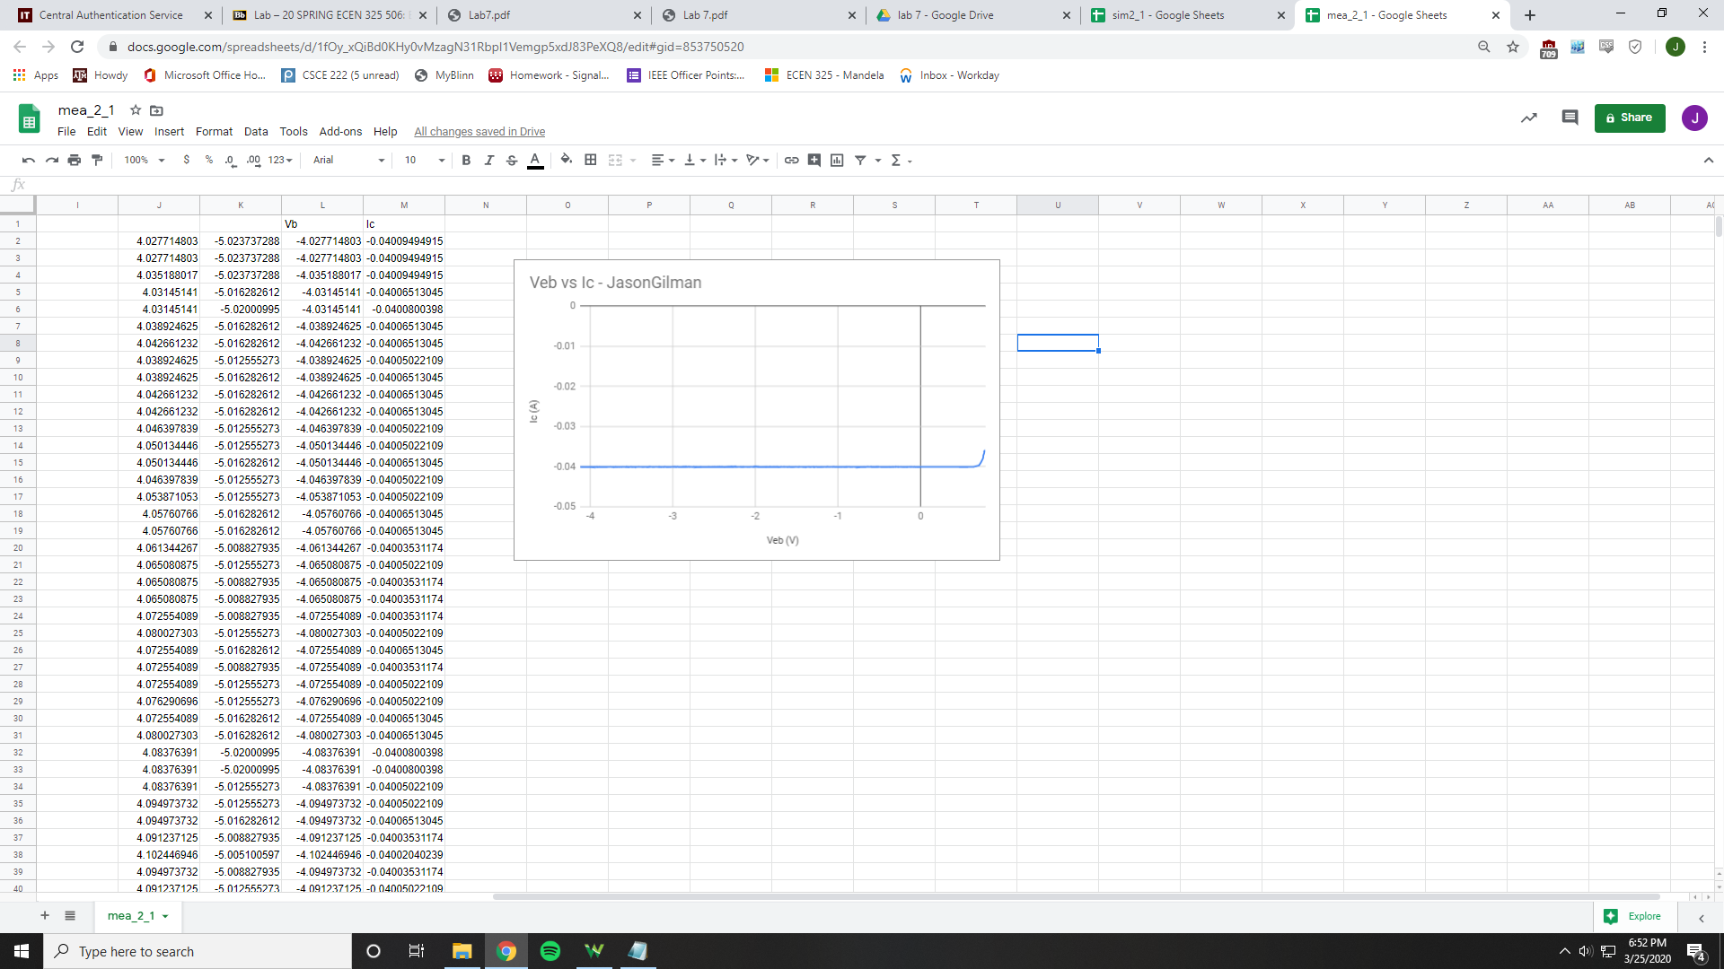

V2 Sweep

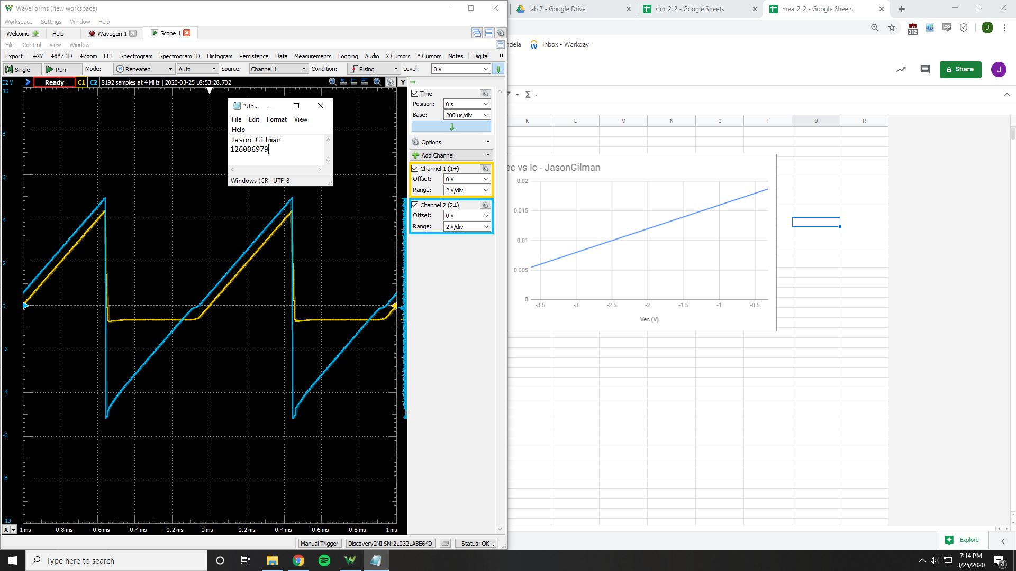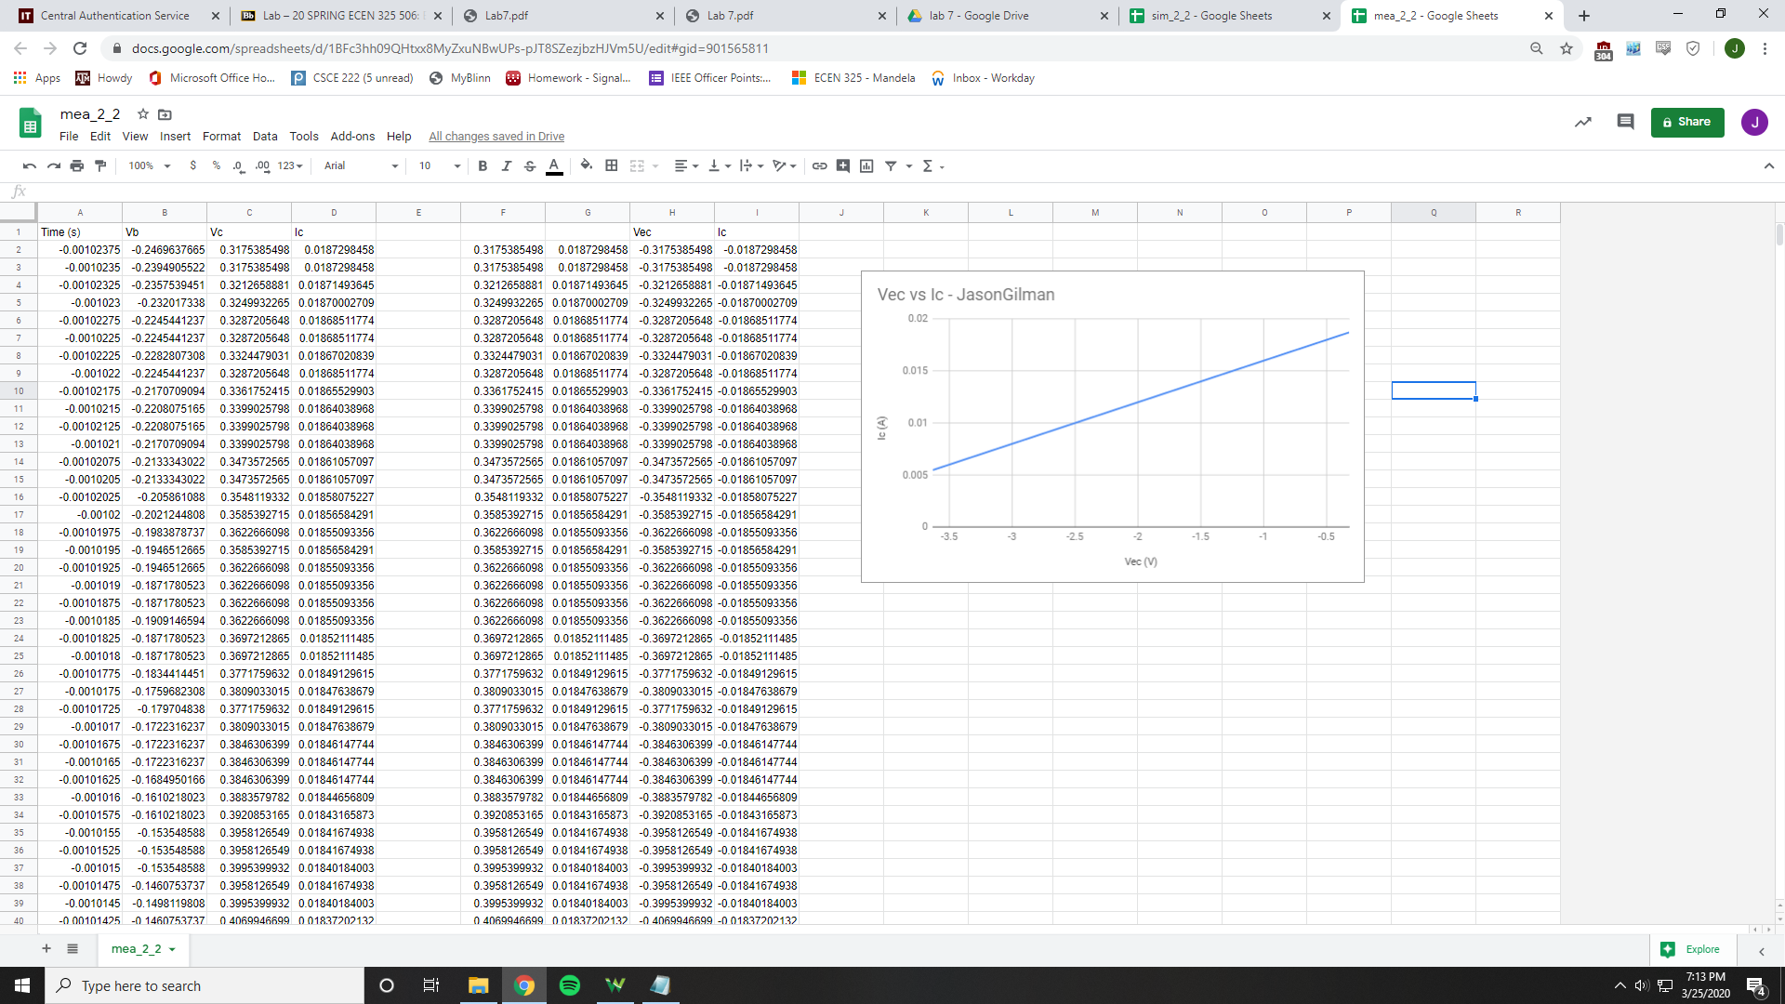

Resistive NPN

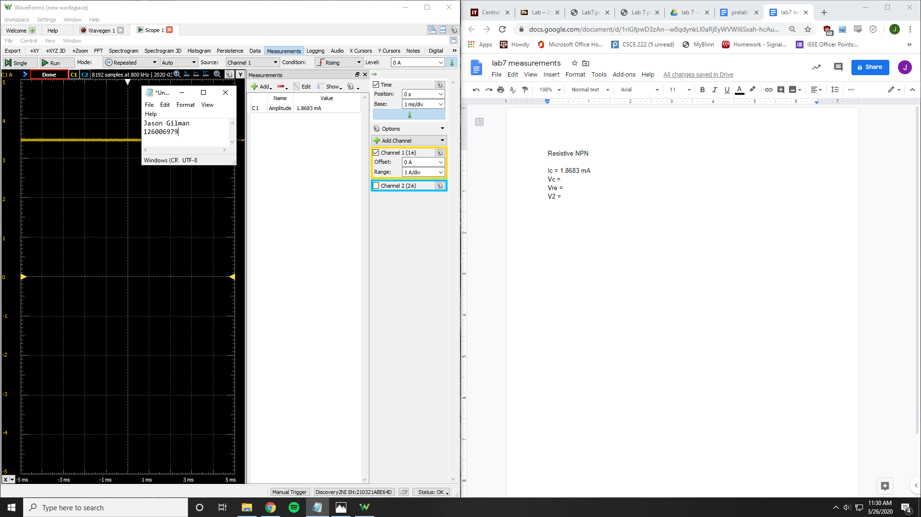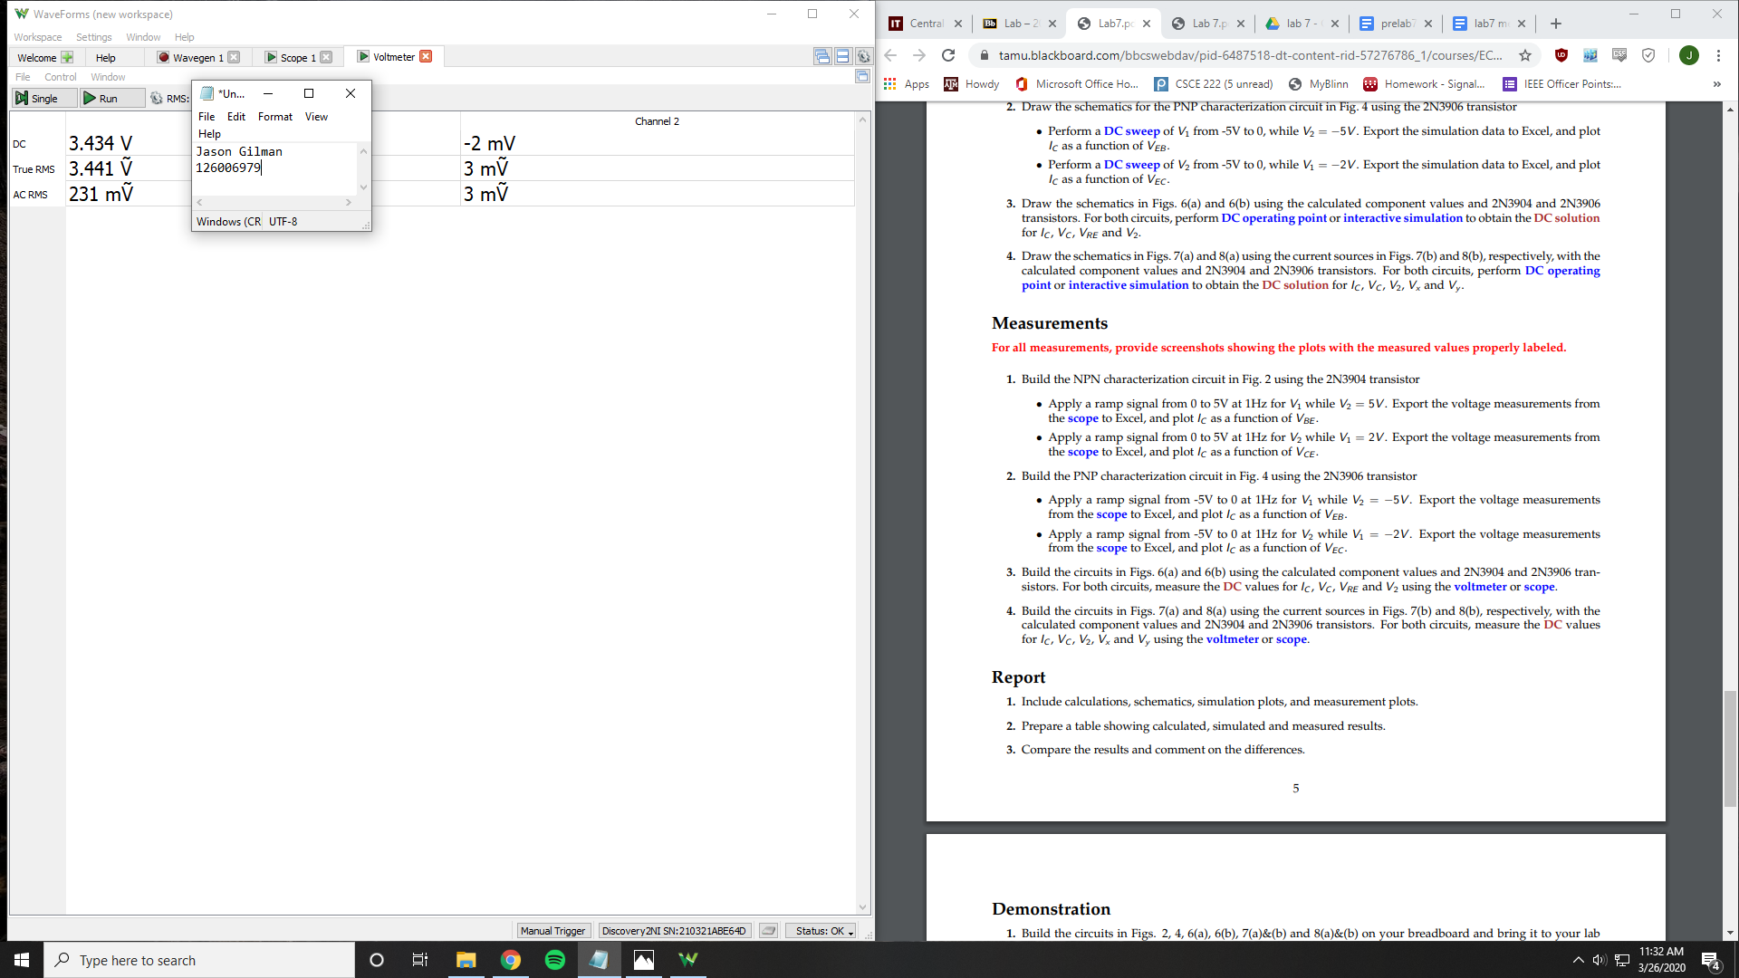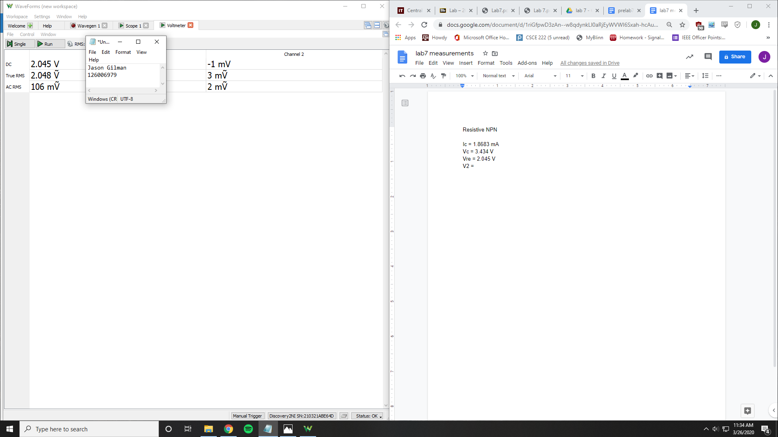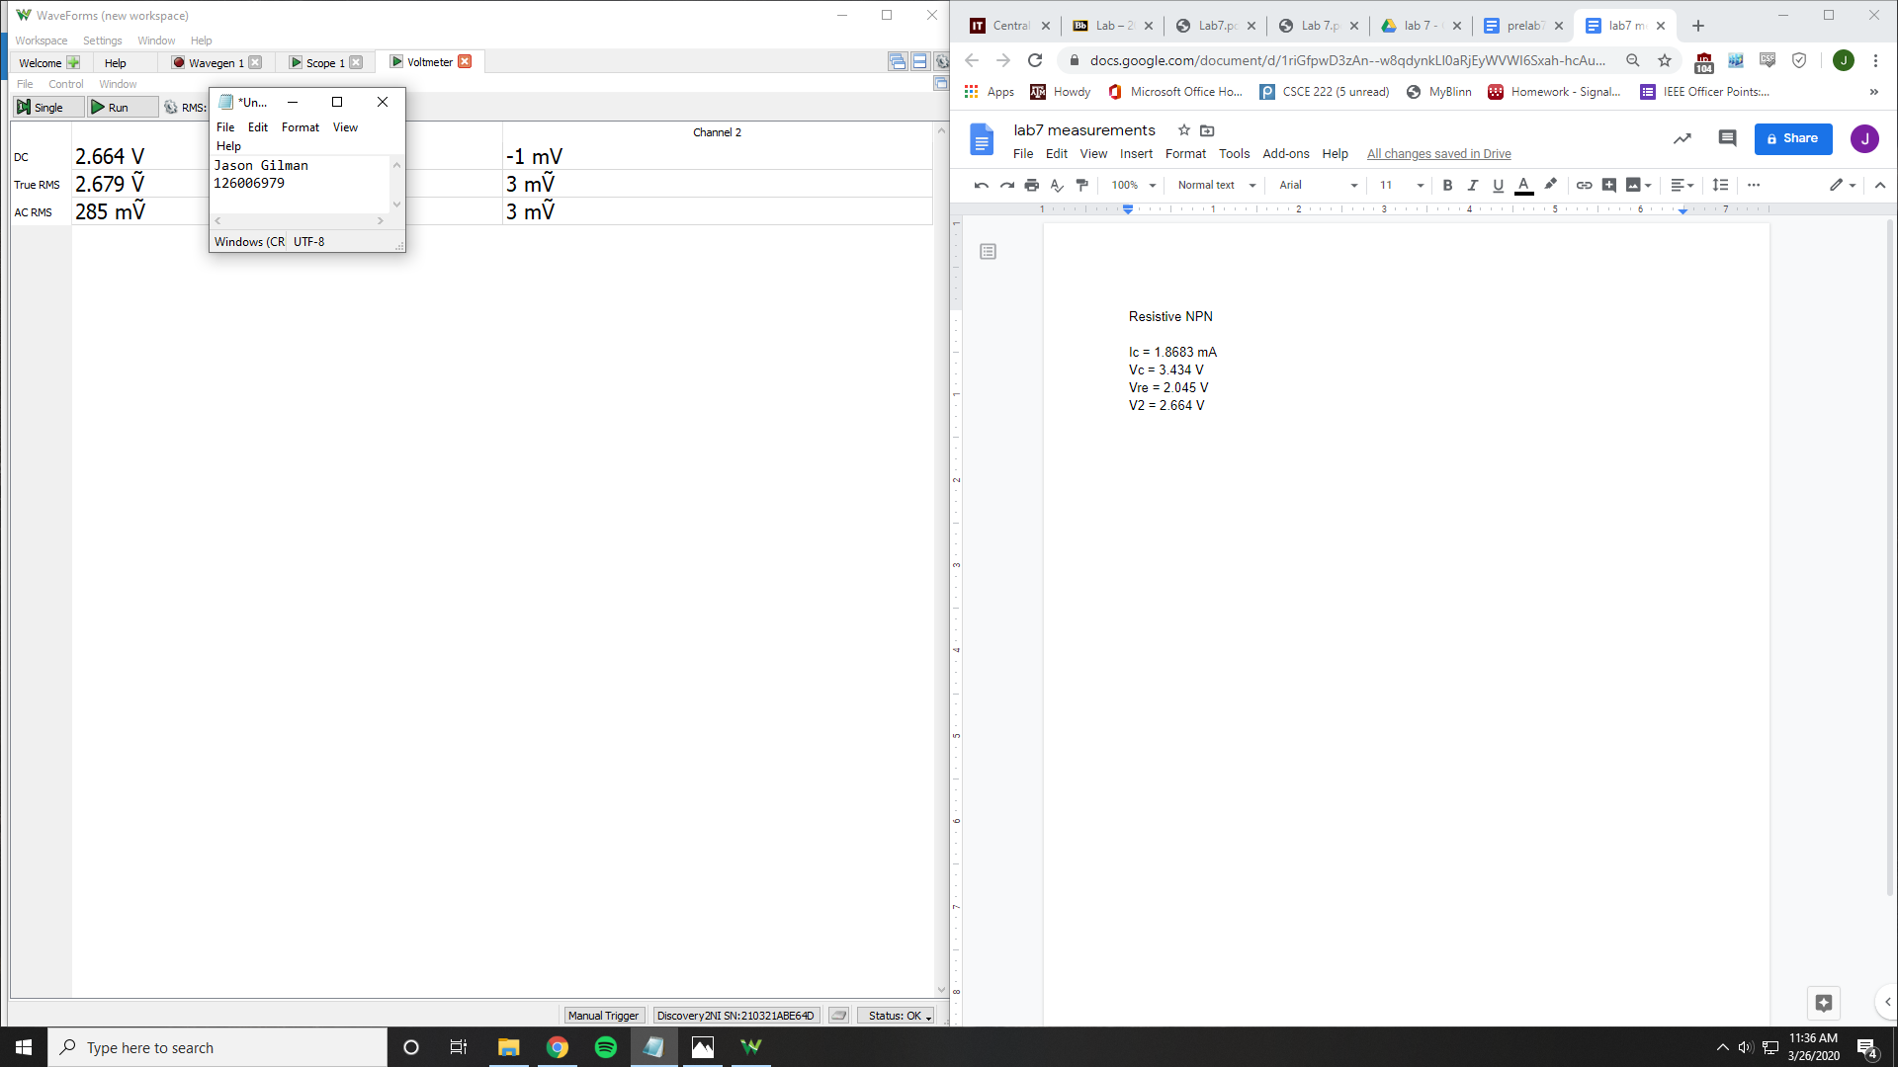

Ic = 1.8683 mA

Vc = 3.434 V

Vre = 2.045 V

V2 = 2.664 V

Resistive PNP

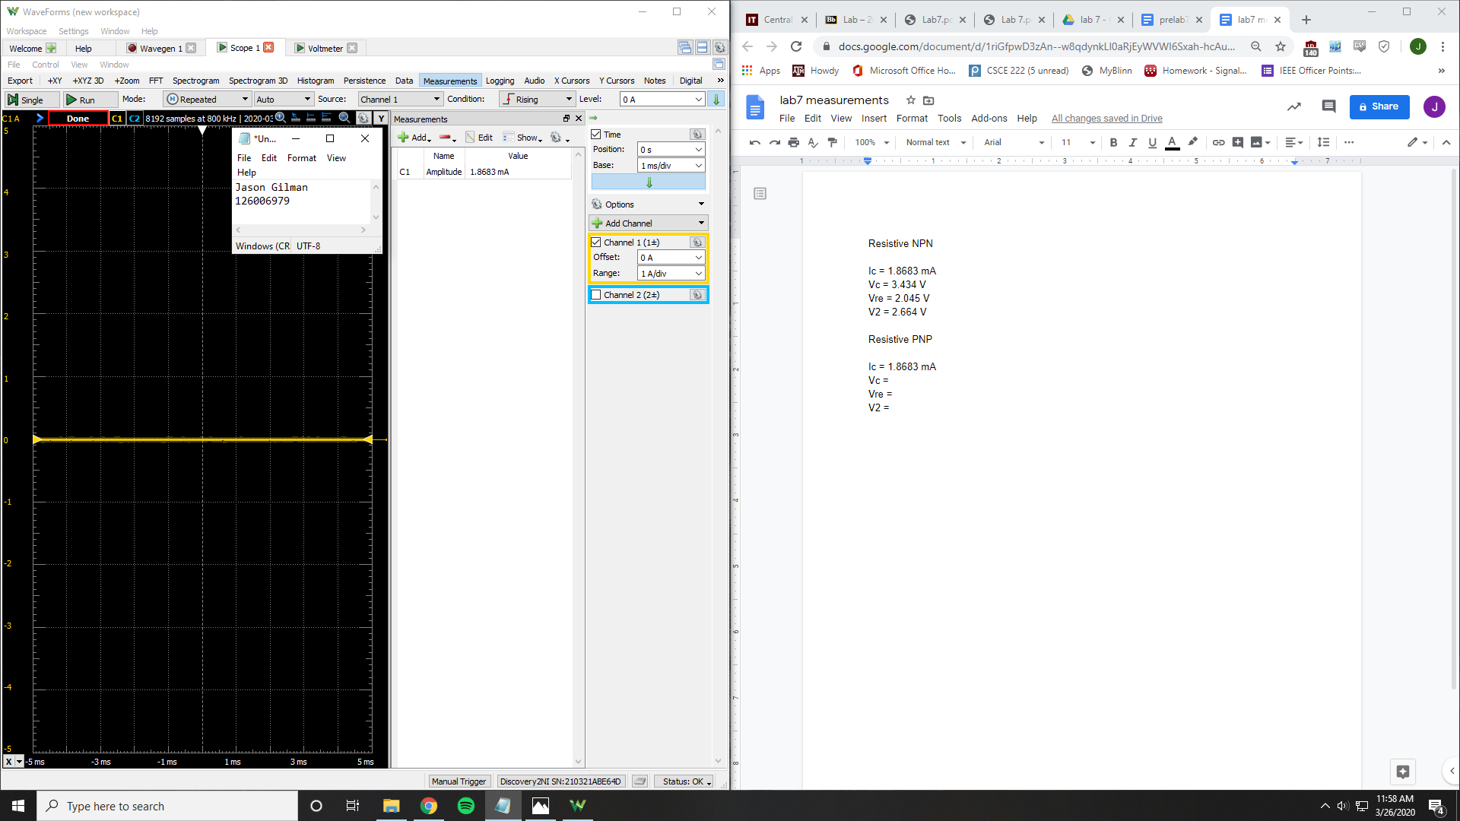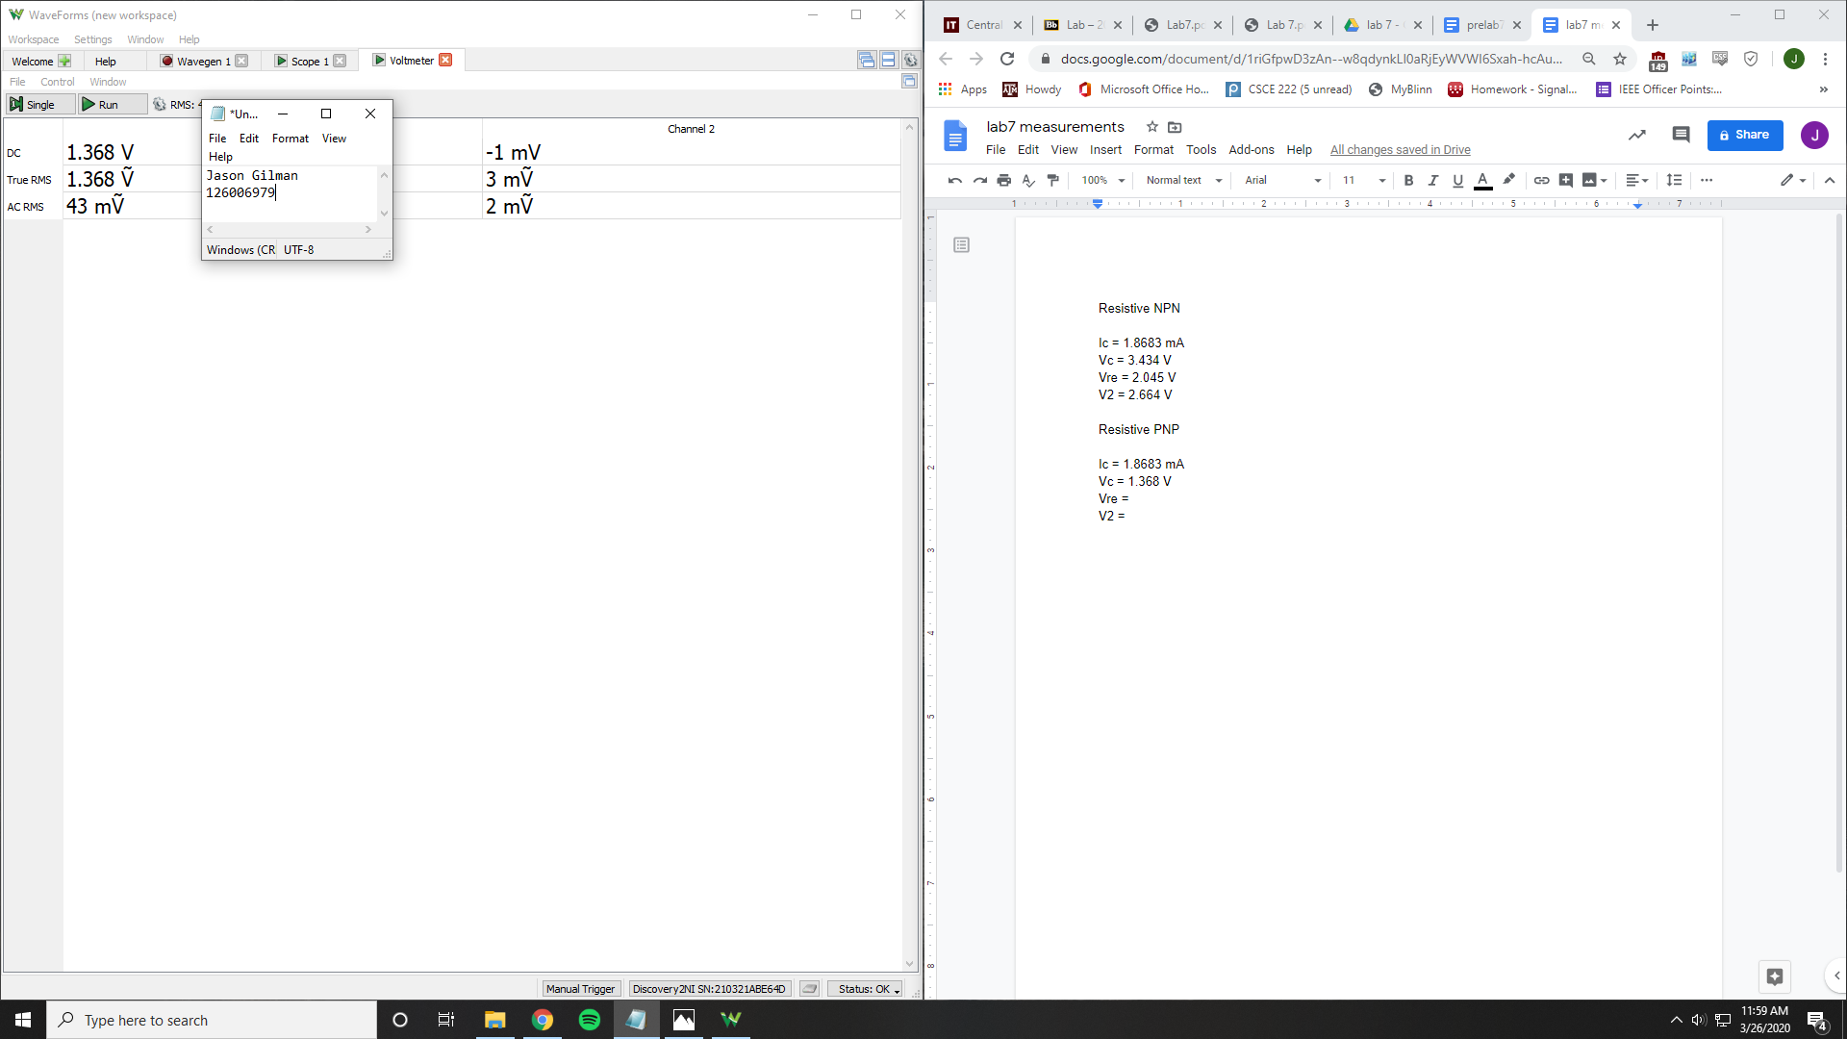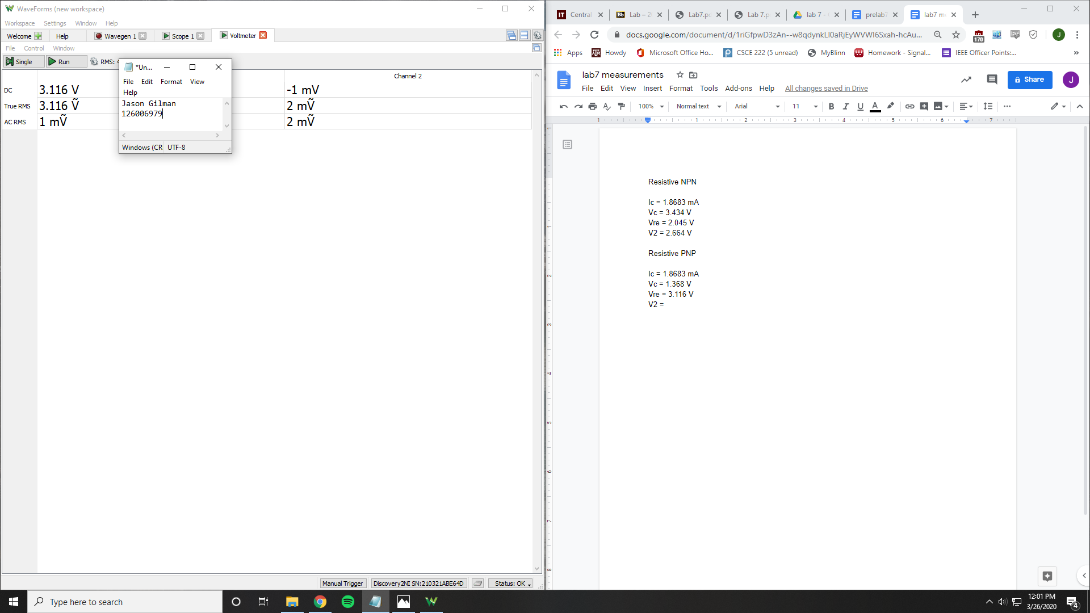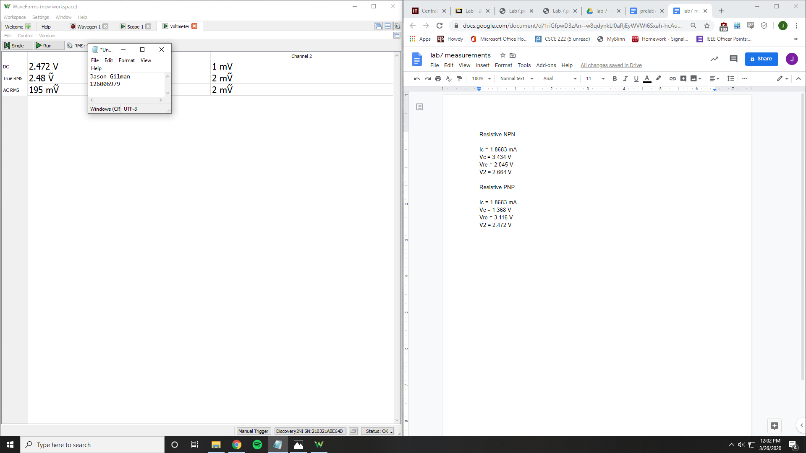

Ic = 1.8683 mA

Vc = 1.368 V

Vre = 3.116 V

V2 = 2.472 V

Current NPN

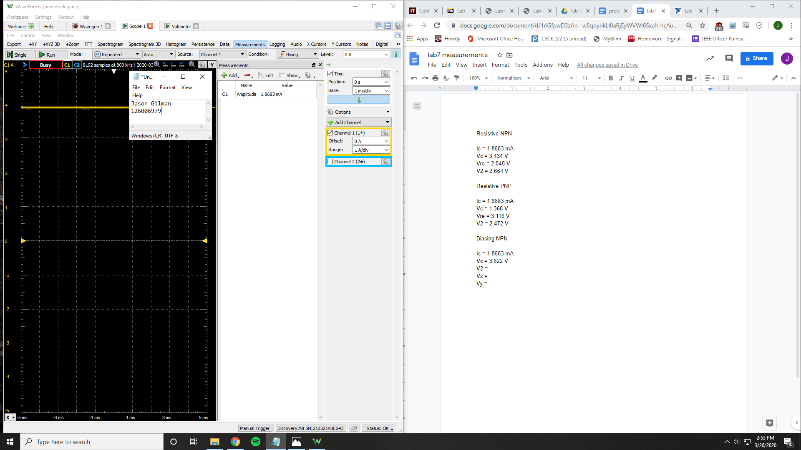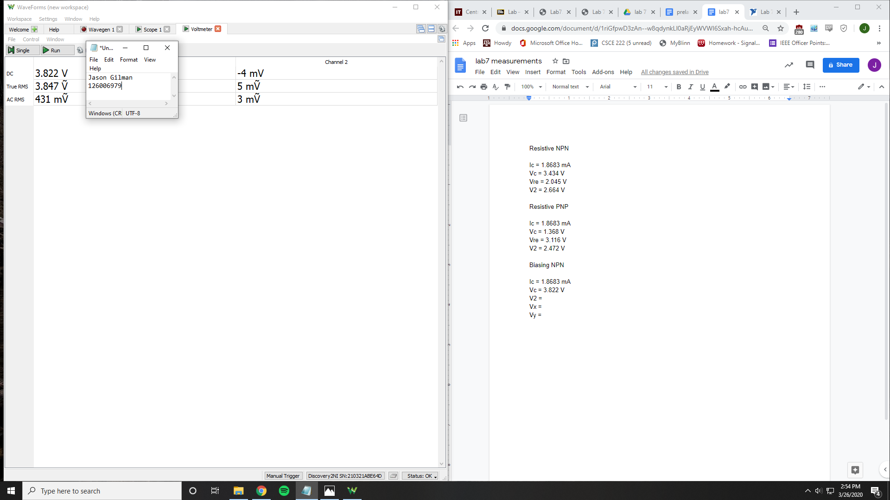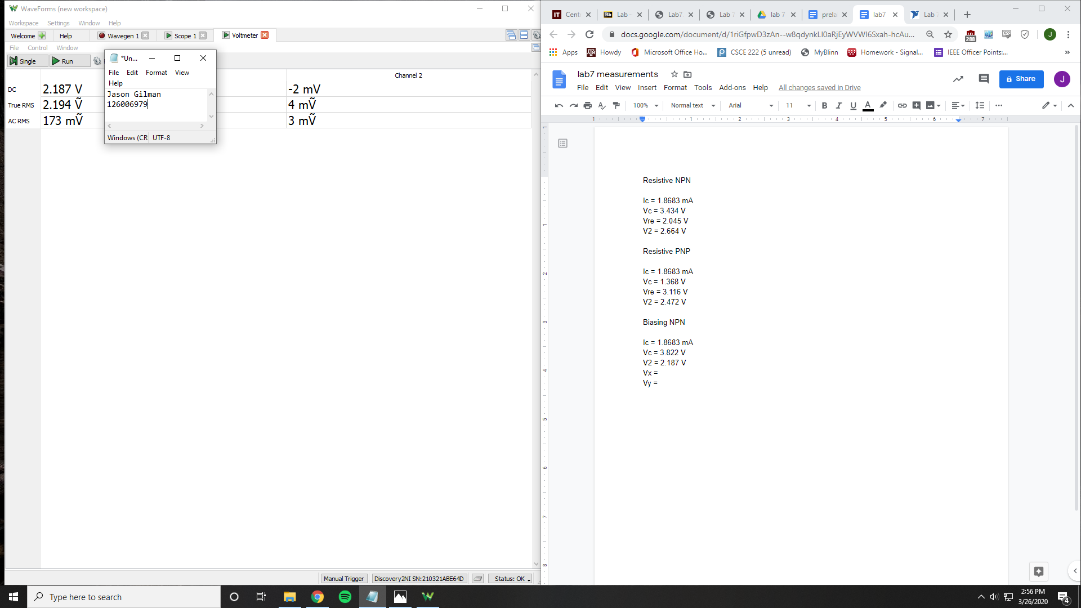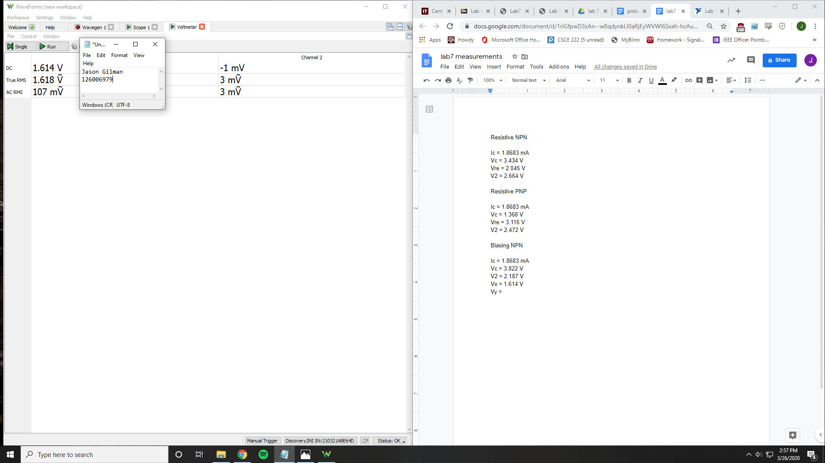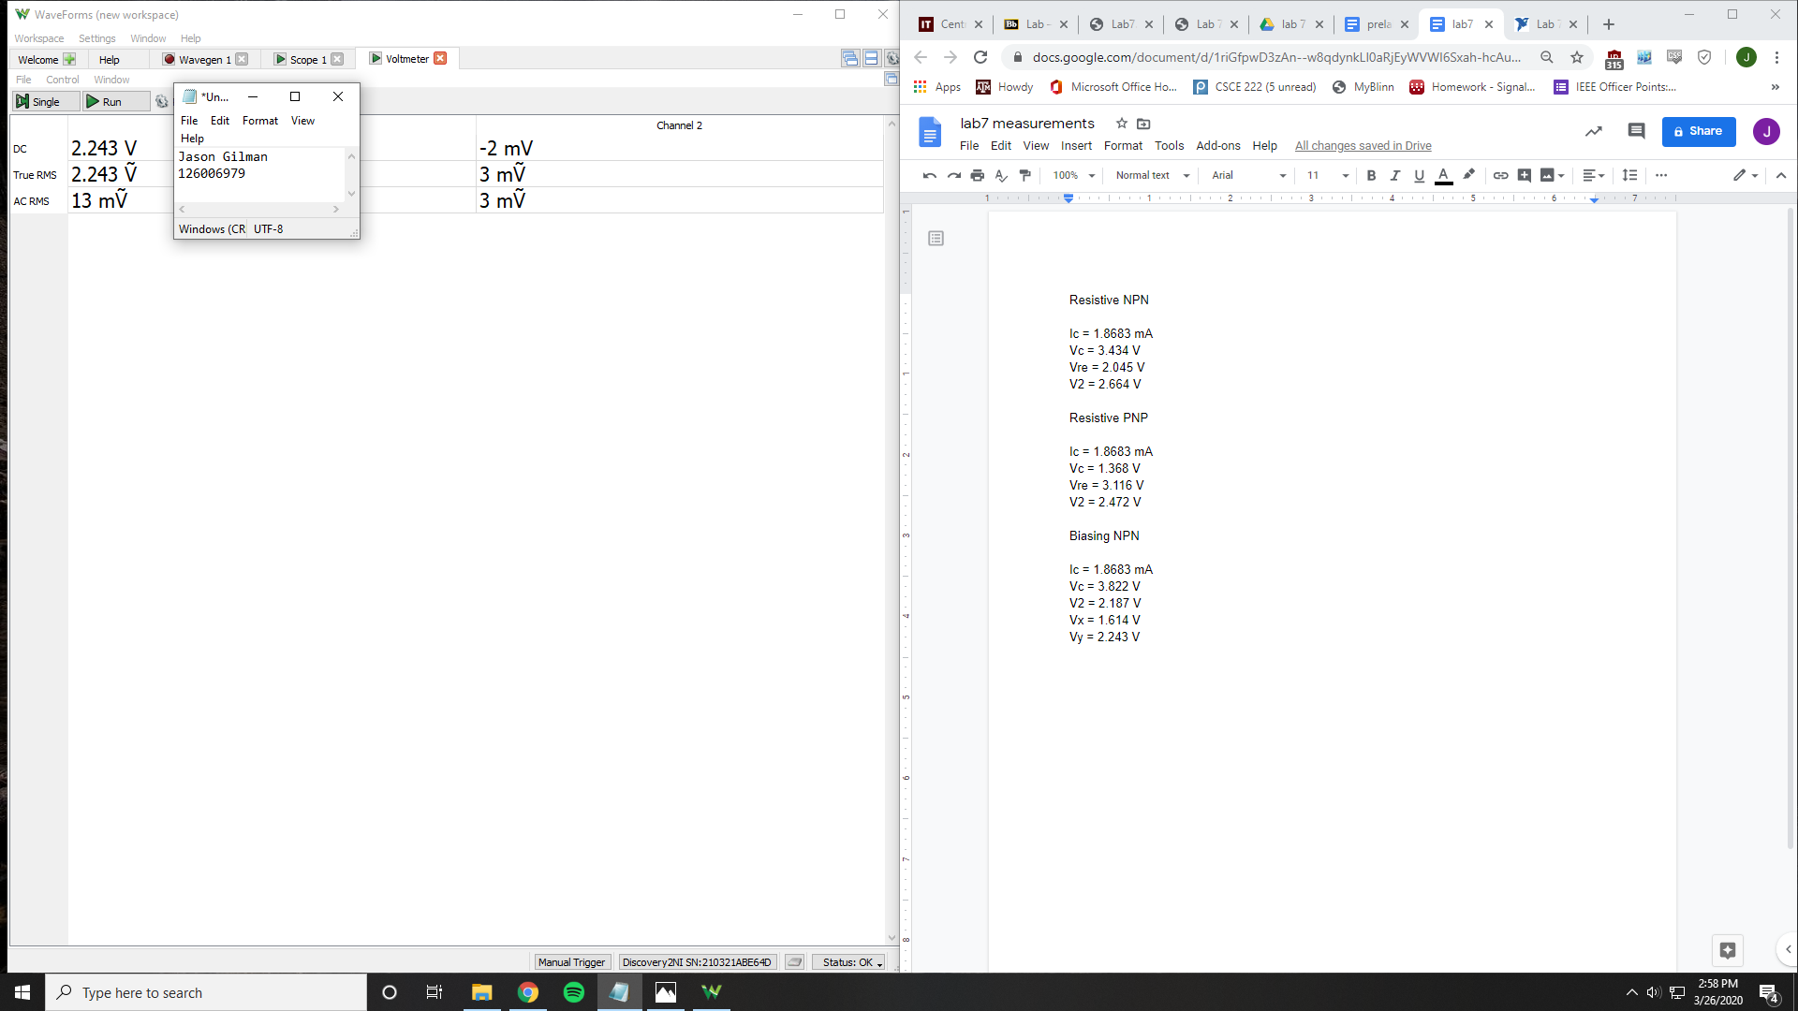

Ic = 1.8683 mA

Vc = 3.822 V

V2 = 2.187 V

Vx = 1.614 V

Vy = 2.243 V

Current PNP

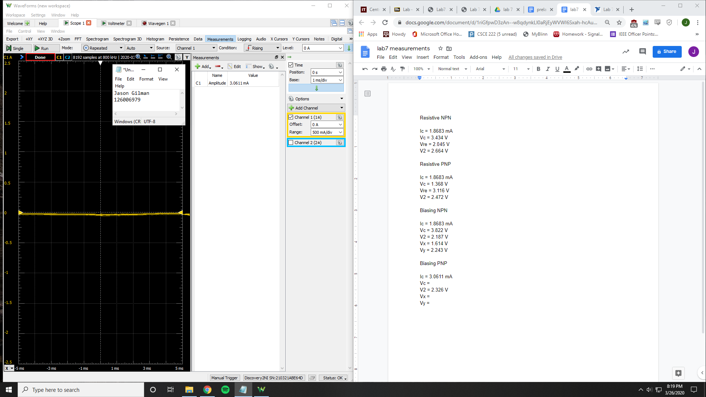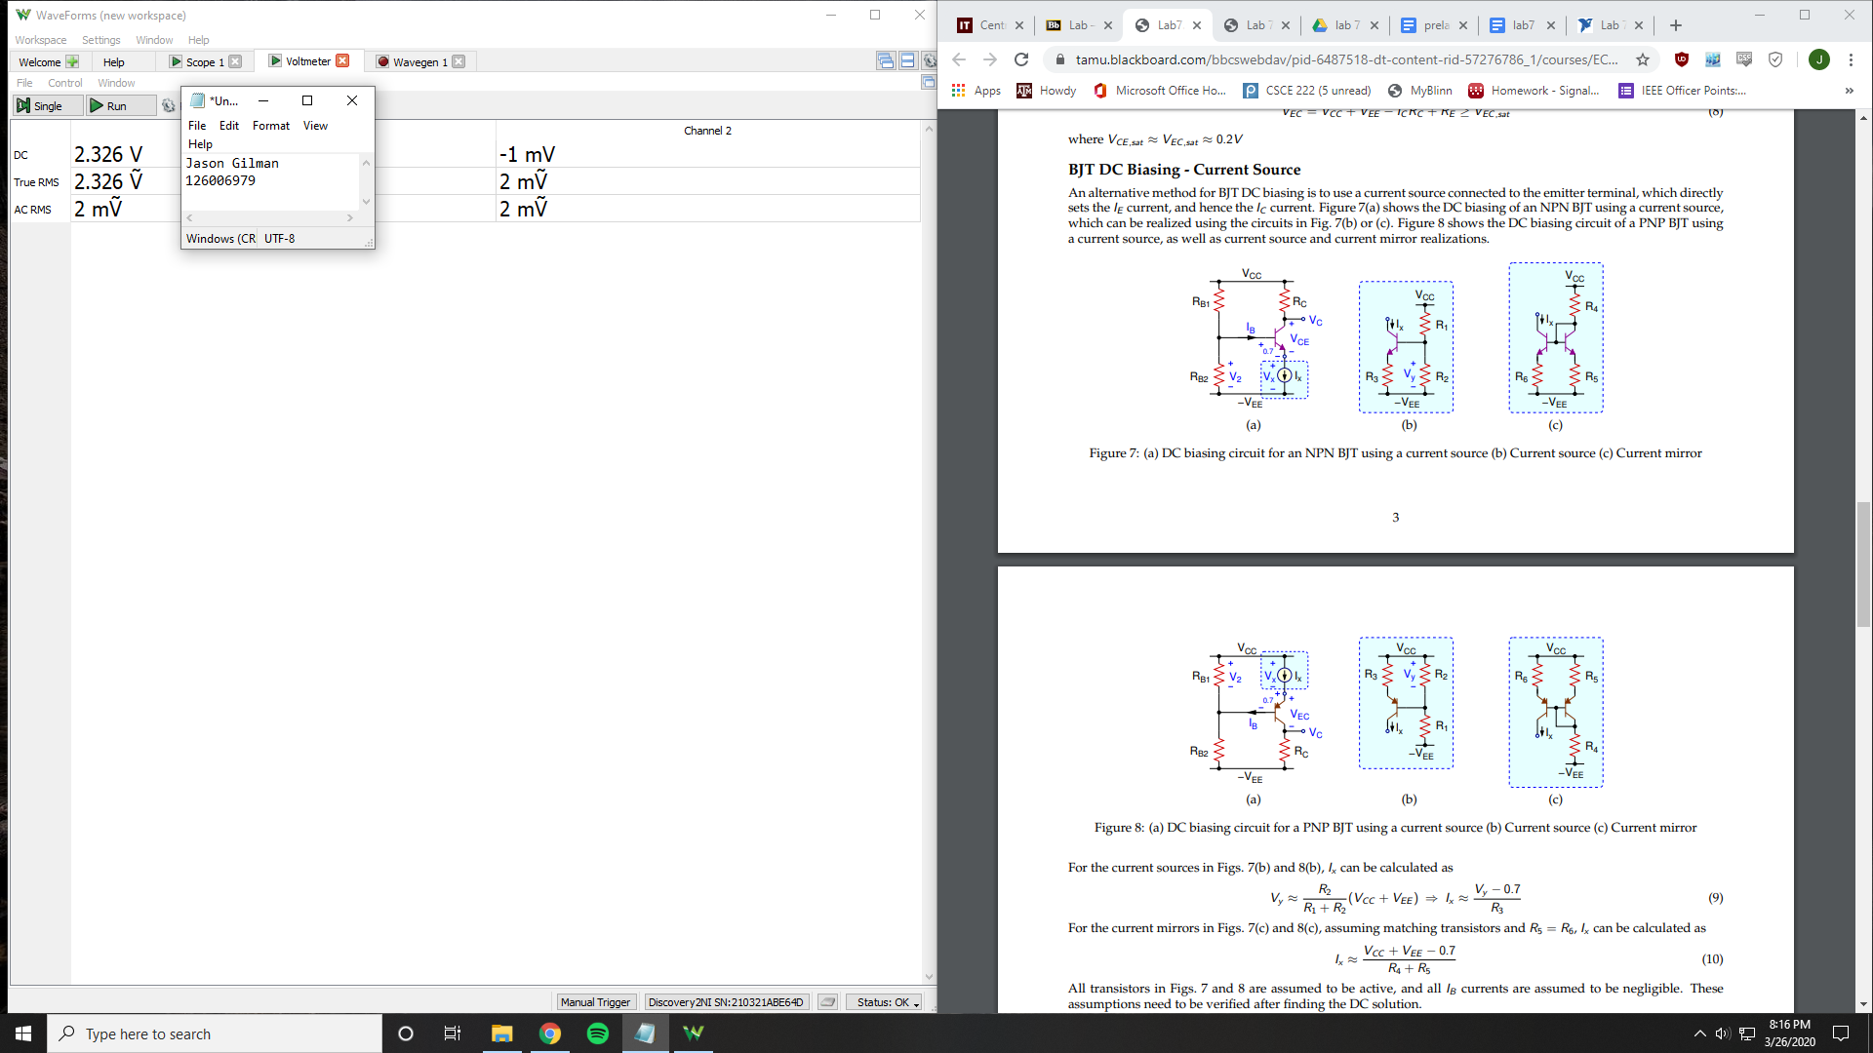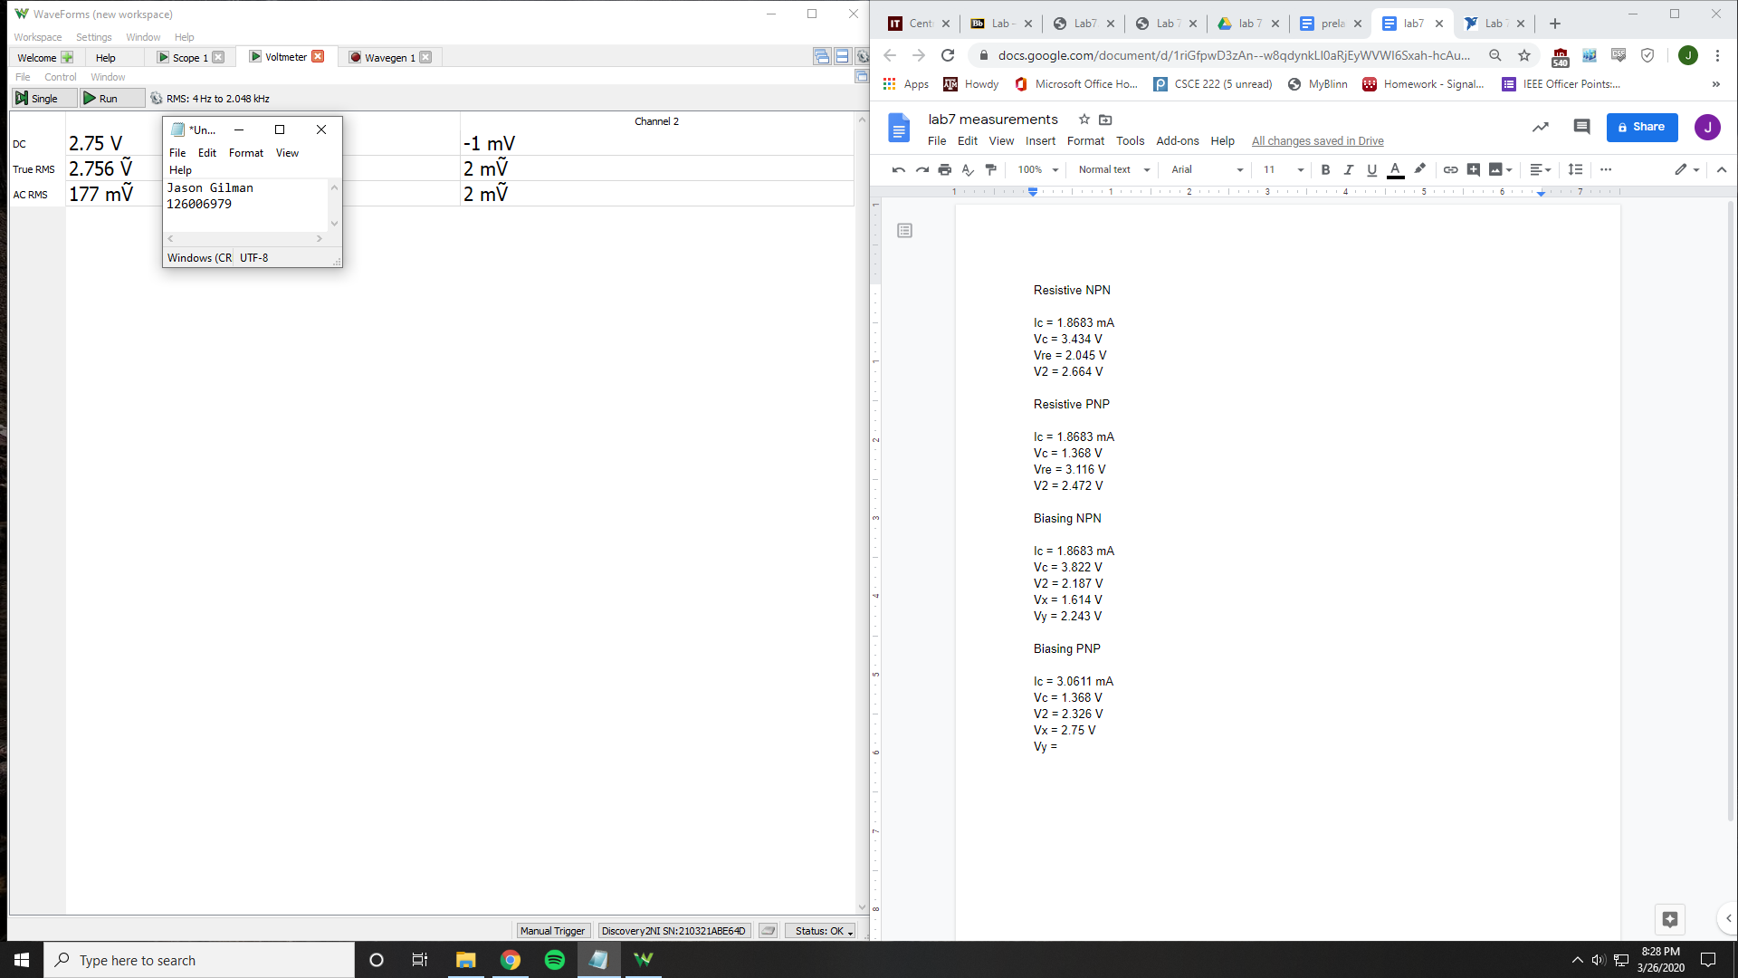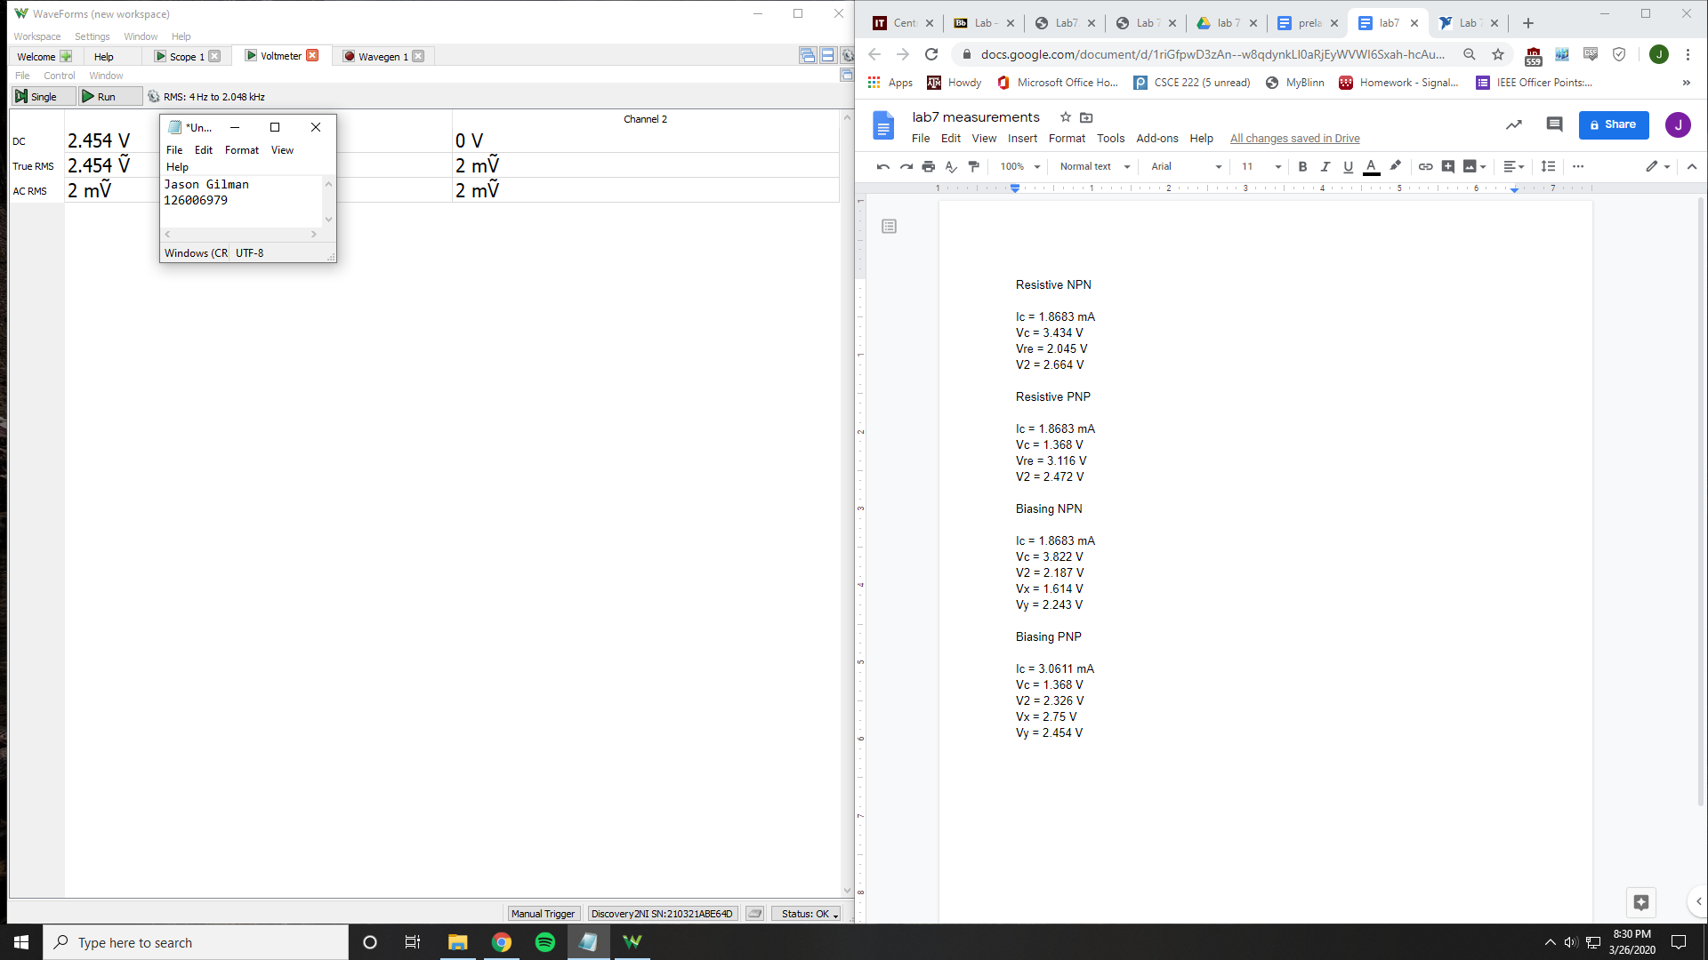

Ic = 3.0611 mA

Vc = 1.368 V

V2 = 2.326 V

Vx = 2.75 V

Vy = 2.454 V

|  |  |  |  |
| --- | --- | --- | --- |
|  | **Calculated** | **Simulated** | **Measured** |
| **Resistive** |  |  |  |
| **NPN** |  |  |  |
| Ic | 1E-3 A | 1.0352E-3 A | 1.863E-3 A |
| Vc | 3.5 V | 3.4472 V | 3.434 V |
| Vre | 2 V | 2.0672 V | 2.045 V |
| V2 | 2.7 V | 2.6890 V | 2.664 V |
| **PNP** |  |  |  |
| Ic | 1E-3 A | 921.76E-6 A | 1.8683E-3 A |
| Vc | 1.5 V | 1.3826 V | 1.368 V |
| Vre | 2 V | 3.1599 V | 3.116 V |
| V2 | 2.7 V | 2.5038 V | 2.472 V |
| **Current** |  |  |  |
| **NPN** |  |  |  |
| Ic | 2E-3 A | 1.6905E-3 A | 1.8683E-3 A |
| Vc | 3.5 V | 3.7322 V | 3.822 V |
| V2 | 2.2 V | 2.4349 V | 2.187 V |
| Vx | 1.5 V | 1.7930 V | 1.614 V |
| Vy | 2.5 v | 2.3803 V | 2.243 V |
| **PNP** |  |  |  |
| Ic | 2E-3 A | 2.1972E-3 A | 3.0611E-3 A |
| Vc | 1.5 V | 1.6479 V | 1.368 V |
| V2 | 2.2 V | 2.4490 V | 2.326 V |
| Vx | 3 V | 3.1367 V | 2.75 V |
| Vy | 2.5 V | 2.5592 V | 2.454 V |

**Conclusion:**

In the table, there is a collection of the values calculated, simulated, and measured throughout the lab. Most of the values are similar regardless of the method of which they were obtained. Some of the differences can be explained by error in the resistor values. The resistors used in the simulation, measurement, and calculation could have all had different values, which could have affected the output values.